

AN EASTER TREASURE FROM GEORGIA EAST AND KRONE VINTAGE-ONLY CAP CLASSIQUE

A Perlemoen Croquettes Recipe Using Sustainable Abalone
To Enjoy With Krone Borealis Vintage Cuvée Brut 2020

Georgia East, highly respected cook, writer, food stylist, photographer and author of West Coast Wander and her beautiful blog East Afternoon, has shared a recipe for divine Perlemoen Croquettes. “These croquettes, based on a recipe from New Free from The Sea (1994, Struik) by the legendary Lannice Snyman and Anne Klarie, are delicious when served as a hot canapé with a few glasses of chilled Krone Borealis Vintage Cuvée Brut 2020”, says Georgia, “with the Borealis’s signature oyster shell aromatics and citrus acidity bringing out the delicate buttery flavour of the abalone.”

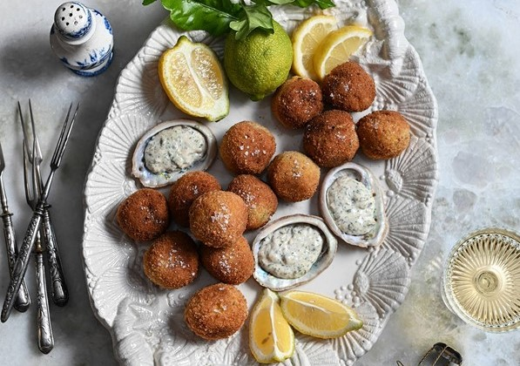

Georgia continues’ “Once a scarcity, perlemoen (Haliotis midae) is now more readily available thanks to largescale aquatic farming along the West, South and East coasts of South Africa. Reared in tanks pumped with fresh seawater, this herbivorous sea snail can be enjoyed ethically, sustainably and is a lot more affordable than in previous decades. This is a tasty talking point as most South Africans wouldn’t have had perlemoen since their childhood (or ever before).

This recipe for perlemoen croquettes makes the most out of the smaller univalves, combining minced perlemoen meat with potato, spring onion and parsley before being deep-fried to a golden crisp.

As abalone are slow growing, farmed perlemoen will be smaller than their wild counterparts, but no less tasty. Wild-caught perlemoen is still highly endangered and is therefore illegal to harvest and should be avoided.”
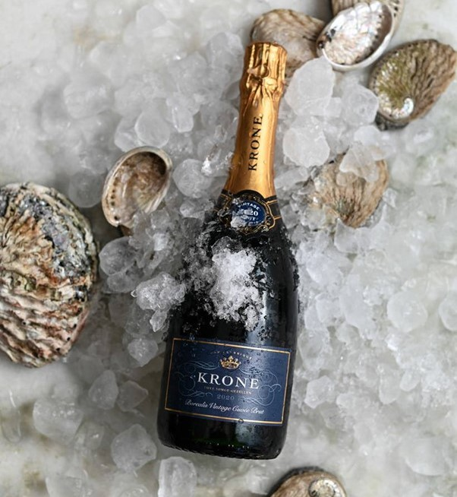

PERLEMOEN CROQUETTES RECIPE

Prep time: 2 hours /Cook time: 15 mins /Makes: 15-25 small croquettes

YOU WILL NEED:

- 6 farmed perlemoen (roughly 500-700g meat)
- 2 large potatoes, peeled and halved
- 3-4 spring onions, trimmed
- 3-4 sprigs of fresh parsley
- Coarse ground sea salt and black pepper
- 2 cups fresh breadcrumbs
- 2 eggs, beaten
- Sunflower or canola oil, for deep-frying

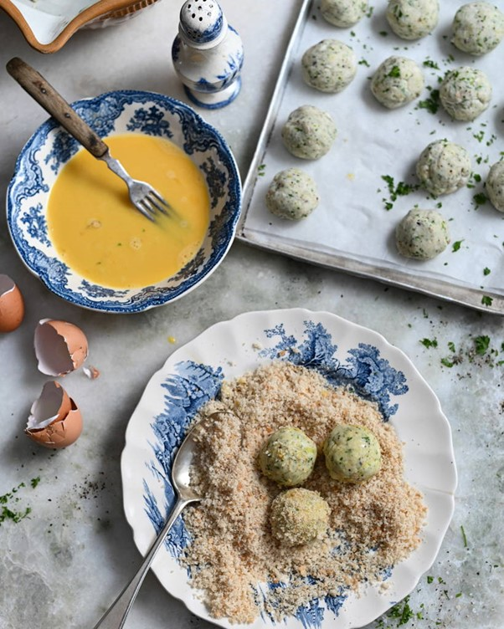

METHOD:

In a pot, cover the potatoes with water and boil until soft. Drain and refrigerate.

To prepare the perlemoen, stun it on the mouth area with a heavy object like a mallet. Use a blunted knife or spatula to carefully lever the perlemoen from its shell. The univalve is attached in the same way as an oyster or mussel so aim to slice through the foot without rupturing the stomach sac. Once out of the shell, use kitchen shears to snip away the viscera and the frilly “skirt” that runs around the periphery of the perlemoen. Use a hard-bristled brush to scrub away any black slime and rinse each prepped perlemoen under cold running water. Place the perlemoen on to a cutting board and using a very sharp knife, slice the perlemoen first into strips and then into small squares. As the perlemoen is diced, there’s no need to tenderise it.

Place the diced perlemoen into a food processor and add in the cold boiled potatoes, spring onions and parsley. Season the mixture with salt and pepper and blitz until combined. Using clean hands, pinch off the mixture and roll into small balls, about 3cm in diameter. Arrange these balls on a lined baking sheet and refrigerate for a minimum of an hour to firm up.

When ready for cooking, heat about 4-5cm of oil in a large pot. Roll the perlemoen croquettes first in the beaten egg and then in the breadcrumbs. Repeat for a doubly crispy coating. Fry the croquettes in batches for 2-4 minutes, turning once, until golden and crisp. Use the slotted spoon to remove the croquettes, allowing them to drain on kitchen towel.

Sprinkle a little sea salt over the croquettes and serve with tartare sauce, fragrant chutney or mayonnaise mixed with finely chopped parsley and capers.

And enjoy with a few glasses of chilled Krone Borealis Vintage Cuvée Brut 2020.

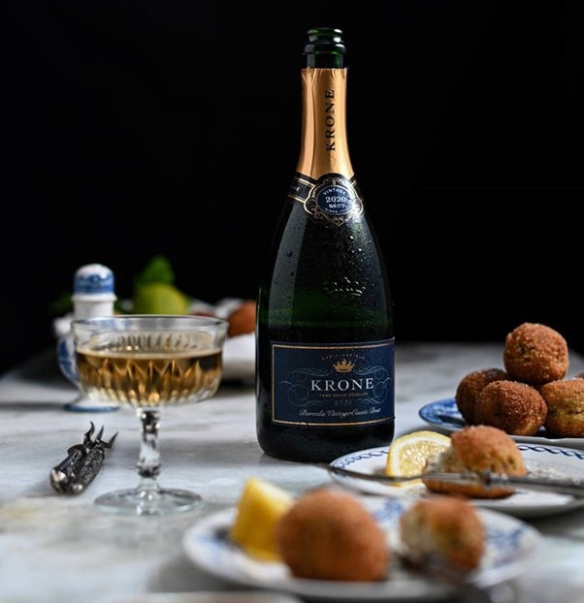
KRONE BOREALIS VINTAGE CUVÉE BRUT 2020

BLEND: Chardonnay 67%, Pinot Noir 27%, Pinot Blanc 6%

TASTING NOTES: The scent of ice, cool and mineral on opening. Calling to mind the snow-capped peaks of the Saronsberg of winter 2020, the arc of mountains surrounding the vineyards of Twee Jonge Gezellen. The characteristic oyster shell of the Borealis is there, flinty and intense, alongside powdery white flowers, white peach and crisp green apples. The palate is energetic and tight due to the cooler growing conditions of this vintage; the fruit is fresh and clean against a chalky texture; limpid peach and melon grow and evolve into glacé pineapple and a whip of lemon curd. Extended time on the lees (18 months) delivers a biscuity intensity, a fine, persistent bubble and a long, radiant finish.

FOOD PAIRING: Krone Borealis evokes a sense of discovery in dining - in a pure and natural way. The saline complexity of the Borealis elevates the oceanic, making the ideal pairing for the simplest of seafoods, ideally served on the beach.

PURCHASE: Krone Vintage Borealis Cuvée Brut 2020 is available for purchase at the estate, online at https://www.kronecapclassique.co.za/collections/vintage-mcc and are widely available nationally at select liquor retailers and grocers.

APPROXIMATE RETAIL PRICE: R190 per 750ml bottle

VINTAGE ONLY CREATION

The making of vintage-only Krone Cap Classique is a commitment to the vintage showcasing the character of each harvest and celebrating a moment in time and place, the unique hallmarks of every vintage as directed by nature: from soil to vine to bottle. Each vintage tells a story. The Krone winemaking team channels the rain, the sun, the wind into structure, complexity and balance - and seals it all with a cork.

TWEE JONGE GEZELLEN

Established in 1710, a national monument with over 300 years of history, Twee Jonge Gezellen in Tulbagh is the treasured home of Krone, a collection of Vintage-Only, terroir-driven Cap Classiques handcrafted in the traditional method in Krone’s historic underground cellar from the finest most distinctive grapes.

Family-owned, the Rands family purchased the farm in 2012. Brother and sister, Svend and Abigail are involved intimately in all aspects of the estate, from vineyard plantings to marketing. Cellarmaster Rudiger Gretschel leads the winemaking division, a renowned Cape winemaker he pours his considerable knowledge into both the viticulture as well as the vinification, working seamlessly alongside Cap Classique specialist and head winemaker Stephan de Beer.

In 2017 the historic estate was reimagined with the interior design being inspired by its rich heritage and original architecture. Today, after lengthy restoration, the farm is both redolent of its history as well as burgeoning with contemporary relevance.

Taste Krone’s vintage Cap Classiques soaking up the majestic views of picturesque valley and the Winterhoek, Witzenberg and Obiqua Mountains.

The KRONE X WHATIFTHEWORLD GALLERY is a collaborative space offering an immersive experience showcasing African contemporary art in the heart of Tulbagh. Now home to an Artist Residency Programme too.

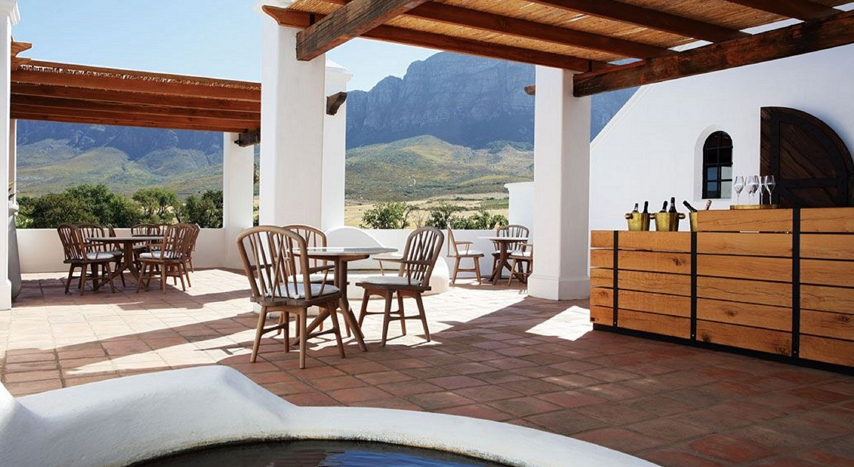

TASTING ROOM & GALLERY OPENING HOURS

Monday - Saturday: 10:00 - 16:00
Twee Jonge Gezellen is closed on Sundays and Public Holidays

CONTACT DETAILS

Tel: 023 230 0680
Email: info@kronecapclassique.co.za
Website: kronecapclassique.co.za
Facebook: facebook.com/KroneCapClassique
Twitter: @KroneCC
Instagram: @kronecapclassique

Prepared by: Krone:
Posy Hazell ∙ PR & Social Media Consultant Contact: Abigail Rands
E-mail: posy@hazell.co.za E-mail: abigail@abigailrands.com

