

DARK CHOCOLATE TRUFFLE TART WITH FAT bastard PINOTAGE

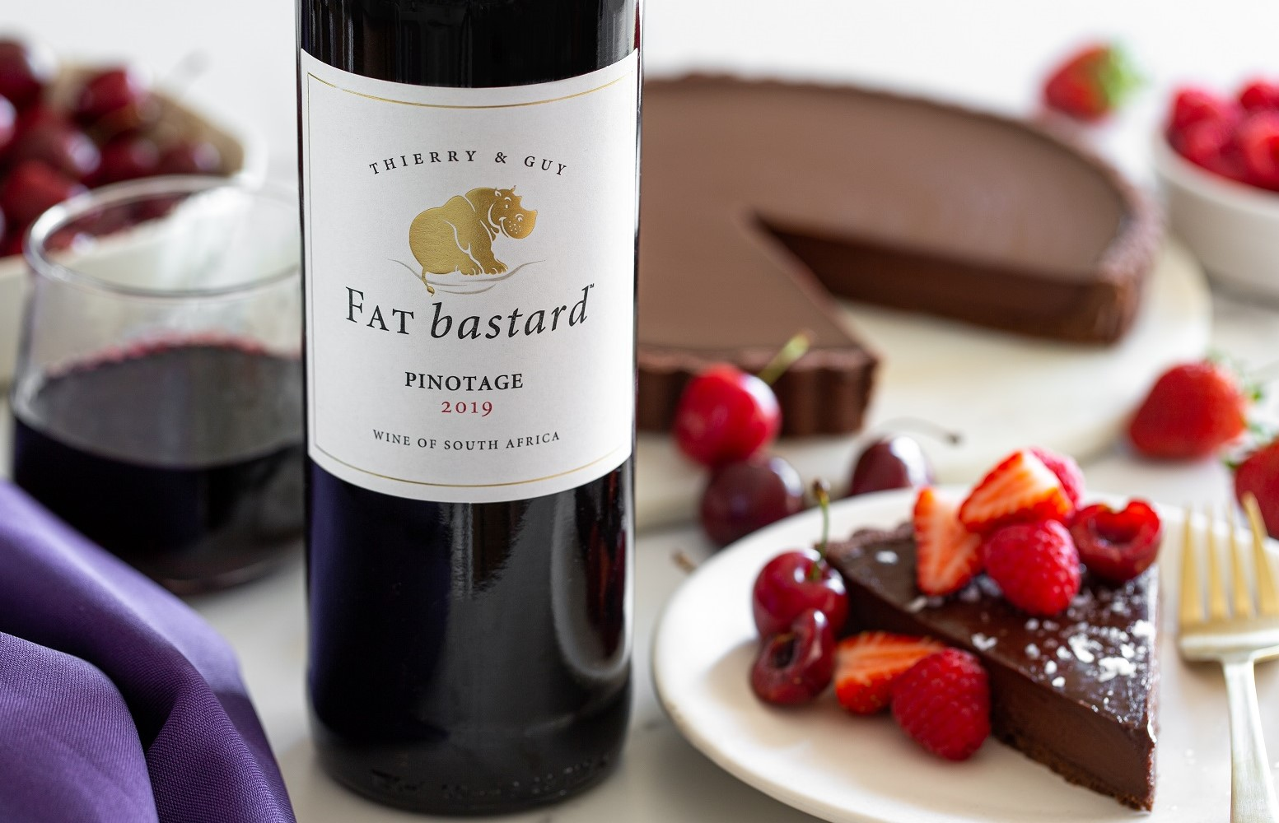

SERVES 12

INGREDIENTS:
Pastry:
- 90g icing sugar
- 25g cocoa powder
- 30g ground almonds
- 120g butter, softened
- Pinch sea salt
- 1 XL free-range egg
- 220g all-purpose flour

Filling:
- 300g high quality dark chocolate, 70%
- 350ml cream
- 50g honey

Special equipment: 24cm tart mould

To serve: Flaky sea salt and fresh seasonal berries

METHOD:
To make the base:
- Weigh icing sugar, cocoa powder and ground almonds in the bowl of a stand mixture.
- Whisk them together to combine well.
- Add the softened butter and salt. Mix on low with the paddle attachment until well combined but do not whip air into the butter.
- Add the egg and mix until combined.
- Add the flour in 3 stages. Once the flour is just incorporated, switch off the mixer.
- You do not want to overwork the dough.
- Flatten pastry dough into a disk and wrap with cling film.
- Place in the fridge to rest for one hour.
- (Dough can be made the night before and also can be made by hand.)
- Flour a clean work surface and remove the dough from the fridge.
- Roll out the dough into a circle a few centimetres larger than your tart mould.
- Gently transfer your dough to the mould by rolling the pastry up on the rolling pin and then unrolling it across the mould.
- Press the pastry dough well into the mould taking special care of the ‘corners’ where the base and sides meet.
- Using a paring knife, trim off the excess dough and neaten the edges.
- (Top tip: save cut offs and turn them into little chocolate biscuits.)
- Place the tart base in the fridge for 30 minutes.
- Preheat oven to 170˚C.
- Prick the base of the tart with a fork.
- Bake for 20-25 minutes.
- Allow the tart base to cool completely before removing the mould and placing the tart base on your chosen serving dish.

To make the filling:
- Prepare a bain marie and roughly chop the chocolate.
- Melt the chocolate in the bain marie, stirring occasionally.
- In another saucepan heat the cream and honey.
- Once the chocolate has melted, remove from the heat.
- Pour the warm cream into the chocolate in 3 additions, stirring well in between.
- As you add the cream it will look like the filling has split. However, keep mixing with a spatula and it will come together homogeneously and smoothly.
- Pour the warm chocolate filling into your tart base.
- Transfer the tart to the fridge and allow to set.
- Once the tart has set, remove from the fridge and sprinkle with flaky sea salt.
- Slice and serve with a pile of fresh berries

ENJOY WITH A GLASS OF THE LUSCIOUS FAT bastard PINOTAGE: Sumptuous and velvety with an abundance of ripe plums and rich dark fruit intertwined with delicious notes of chocolate and mocha. A perfect accompaniment to a Dark Chocolate Truffle Tart.

The FAT bastard PINOTAGE can be purchased online at https://shop.fatbastardwine.co.za/ and is widely available nationally, retailing at around R120.

Website: http://www.fatbastardwine.co.za/
Facebook: https://www.facebook.com/FATbastardWineSA/
Twitter @FATbastardSA · Instagram @FATbastardSA
Hashtag #LiveLARGE

Issued on behalf of the Robertson Winery by: | Robertson Winery
Posy & Jeremy Hazell PR & Social Media Consultants | Contact: Riekie Viljoen
Cell; 082 557 2968 | Tel: 021 883 8043
Email: posy@hazell.co.za | Email: riekie@robertsonwinery.co.za

