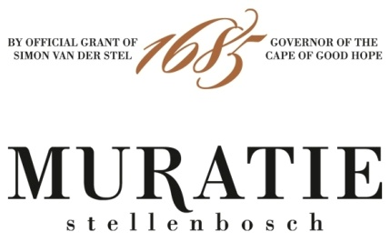

MURATIE ESTATE CELEBRATING HERITAGE THROUGH FOOD AND WINE

At Muratie, ‘where ‘Every Day is Heritage Day’, the culture of food and wine is an intrinsic ingredient of the Melck family’s history, and life at Muratie today. Culinary duo, Annatjie Melck and daughter-in-law Kim Melck are celebrating heritage month by sharing recipes for two of their favourite traditional dishes to enjoy with Muratie wines, all of which pay homage to intriguing personalities intertwined with the historic estate’s centuries-old heritage.

- Waterblommetjie Bredie - to serve with Muratie’s Laurens Campher White Blend
- Slow-Braised Karoo-Style Lamb Shanks - to enjoy with Muratie’s Martin Melck Cabernet Sauvignon

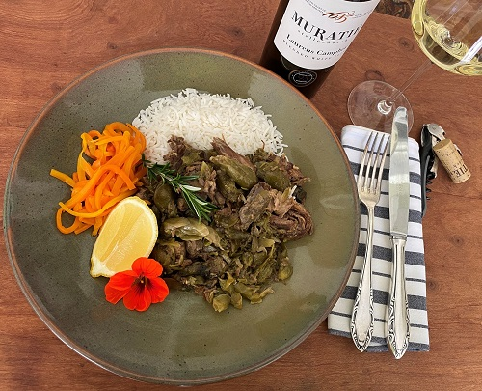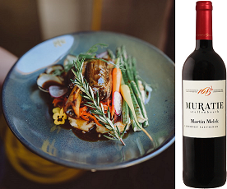
WATERBLOMMETJIE BREDIE - TO SERVE WITH MURATIE’S LAURENS CAMPHER WHITE BLEND

Waterblommetjie Bredie is a traditional Cape gem that was first prepared by the Khoikhoi people. Cooked typically with lamb, the waterblommetjies (‘little water flowers’) grow in dams and ponds in the Cape during winter and spring. Through long, slow cooking, the meat becomes extremely tender, perfectly complementing the subtle yet flavourful waterblommetjies and potatoes.

RECIPE

You need:
- 1kg lamb (a mixture of flatrib and thick rib)
- 15ml brown vinegar
- Salt and freshly ground black pepper to taste
- A sprinkle of nutmeg
- 2 big onions, roughly cut
- 2 garlic gloves, finely chopped
- 2,5kg waterblommetjies, thoroughly washed/cleaned
- 500g potatoes, peeled and sliced in wedges
- 250ml warm water
- Lemon wedges for serving

How to clean the waterblommetjies:
Soak the waterblommetjies overnight in salt water. Rinse and clean thoroughly, removing any sand as well as any hard parts from the flowers and the leaves.

Do the following:
- Sprinkle the vinegar over the meat and flavour with salt, pepper and nutmeg.
- Place the meat in a heavy bottomed pot with a little water, the onions and the garlic and braise the meat until it is nearly soft.
- Add the waterblommetjies to the meat and place the potato wedges on top of that. Flavour with salt, pepper and nutmeg to taste
- Add the hot water, cover the pot with the lid and let the stew cook slowly until the waterblommetjies and the potato wedges are soft.
- Keep boiling water on standby in case you might need more liquid, as the stew should not be cooked dry, and neither should it be like a pot of soup. Do not stir the bredie during the cooking process.
- Only stir the bredie prior to serving in order to mix together the waterblommetjies, potato and meat.
- Serve with white rice and lemon wedges
- Perfect with a chilled glass of Muratie Laurens Campher

MURATIE LAURENS CAMPHER 2019
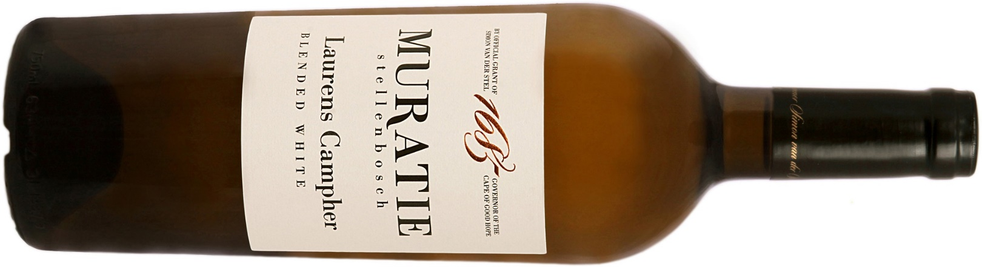

Every wine tells a story at Muratie, the historic Stellenbosch Estate that dates back to 1685.
The story: The Laurens Campher, Muratie’s flagship white blend pays tribute to the first owner of Muratie, the passionate and determined young German soldier who fell in love with a slave-girl at the Castle in Cape Town. During their 14-year courtship, he frequently walked the 64 kilometres to Cape Town and back, a three-day trip, to see his sweetheart Ansela. Eventually Ansela was emancipated in 1699, whereupon she and Laurens married and, with their children, settled on the farm. They planted the first vineyards at Muratie and an oak tree, to bless their marriage, which still stands on Muratie, as does a small white house, their first home, which today houses the MOK Gallery.
Winemaker’s notes: This unique white blend of predominantly Chenin Blanc with smaller amounts of Sauvignon Blanc, Verdehlo and Viognier, is barrel fermented and judiciously oaked in a combination of new and older 500L French Oak barrels for 11 months. An elegant yet intense wine, it shows gorgeous stone fruit flavours of peach and apricot, hints of citrus and a fresh acidity all wrapped in creamy oak.
Purchase: Muratie Laurens Campher 2019 is available at the estate, online at https://www.muratie.co.za/wine/buy-wine/ and at select fine wine merchants around the country.
Approximate retail price: R198

SLOW-BRAISED KAROO-STYLE LAMB SHANKS – TO ENJOY WITH MURATIE’S MARTIN MELCK CABERNET SAUVIGNON

Once again, in celebration of local food, what could be more apt than some delicious South African lamb. Here is Kim Melck’s recipe for her famous fall-off-the-bone lamb shanks, a huge favourite at Muratie’s Farm Kitchen restaurant.

RECIPE

You will need:
- 4 x lamb shanks - each should weigh about 360g
- Oven roasting bag
- ¼ cup balsamic vinegar
- ½ cup water
- ¼ cup oil
- Medium coarse salt
- White pepper
- Fresh spring or two of rosemary

Do the following:
- Pop the 4 shanks into the roasting bag, liberally sprinkle with the coarse salt and white pepper, be generous!!
- Add the water, oil and vinegar to the bag as well as the rosemary.
- Press any excess air out of the bag and tie with a bag tie or just knot.
- Lay the cooking bag containing the shanks in an oven roasting pan and roast at 180 degrees until soft to the touch and beautifully brown.
- Serve on a heap of creamy mashed potatoes, with sweet carrots on the side and green beans or baby peas.
- Even more delicious with a glass of Muratie’s Martin Melck Cabernet Sauvignon

MURATIE MARTIN MELCK CABERNET SAUVIGNON 2017

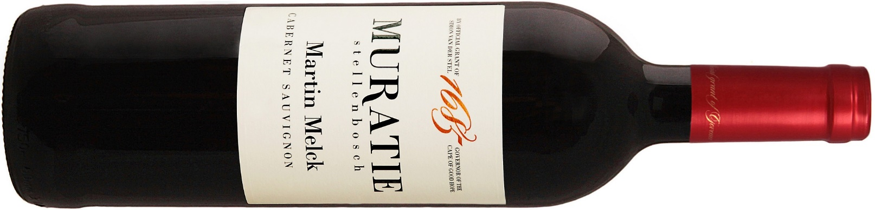

Every wine tells a story at Muratie, the historic Stellenbosch Estate that dates back to 1685.
The story: This wine honours Martin Melck, patriarch of the Melck clan in South Africa, one of the Cape’s greatest landowners and most influential stock-and wine-farmers. Martin bought De Driesprong (Muratie) in 1763 and the farm remained in the hands of his descendants for 134 years, during which time the Muratie manor house was built.
Martin is also acclaimed for building the first Lutheran Church and neighbouring parsonage, known as Martin Melck House, in Strand Street, Cape Town – both Cape Provincial Heritage sites.
Winemaker’s notes: Classically styled and restrained, concentrated dark fruit (black cherries, berries and plums) are underscored by fresh acidity, and framed by cedar wood and spice notes from 20 months in French oak (10% new). This is a full-bodied and complex wine, a wine of integration, balance and great length true to its terroir. This authoritative wine will reward cellaring for at least another 6 years.
Purchase: Muratie Martin Melck Cabernet Sauvignon is available at the estate, online at https://www.muratie.co.za/wine/buy-wine/ and at select fine wine merchants around the country.
Approximate retail price: R240

SIP ON MURATIE WINES AND TASTE HISTORY FOR YOURSELF
Knorhoek Road, Stellenbosch · www.muratie.co.za · 021 865 2330 · info@muratie.co.za

@muratiewine  Muratie Wine Farm

.

