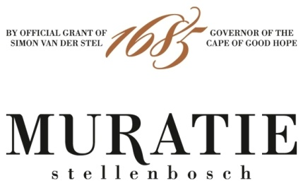

CELEBRATE #GRENACHEDAY WITH MURATIE MR MAY GRENACHE NOIR

PERFECTLY PAIRED WITH ANNATJIE MECLK’S MARROW BONES ON TOAST

It is International Grenache Day on Friday 17th September, so raise a toast to this complex, versatile and intriguing grape with its luscious juicy ripe red fruit flavours, silky tannins, savoury spice and seductive mouthfeel. Grenache also happens to be one of the most adaptable food-pairing wine wines in the world.

Originating in Northern Spain, Grenache spread to the south of France, specifically the Rhône Valley, and around the world, thriving in hot, dry vineyards in six of the seven continents. An important grape for the production of red wines, it also makes excellent rosés and fortified wines. Largely tucked away in Grenache, Shiraz, Mourvèdre red blends (the New World take on the Rhône) and in Châteauneuf du Pape (with a cocktail of other varieties), more and more highly acclaimed single-vineyard bottlings are coming on stream.

Enter Muratie Mr May Grenache Noir!
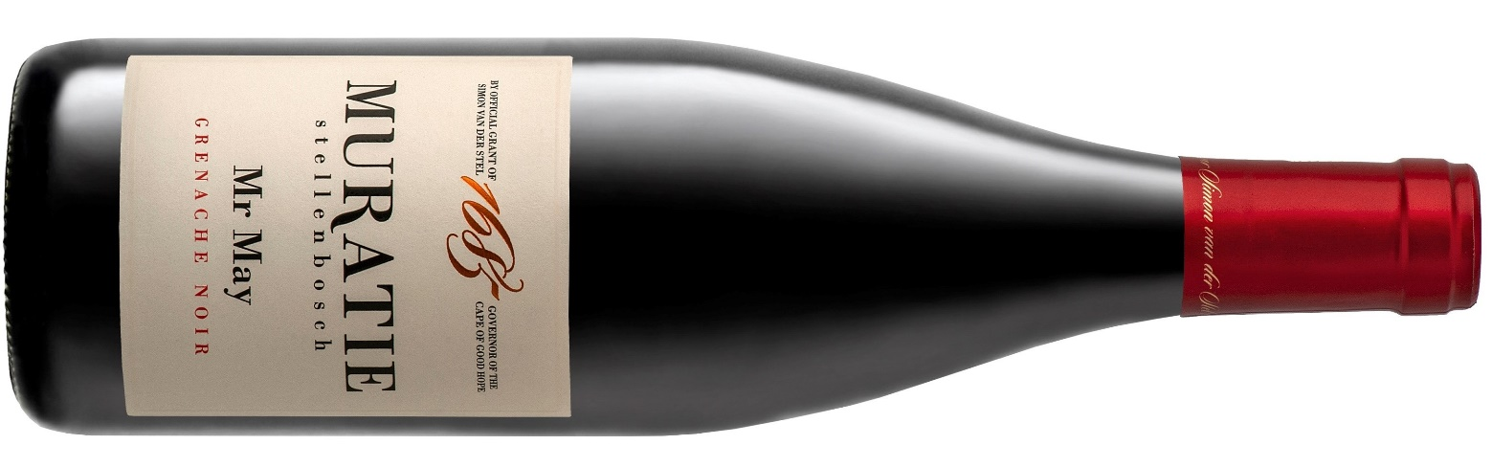And in true Muratie style, where the culture of food and wine is an intrinsic ingredient of the Melck family’s history, and life at Muratie today, Annatjie Melck, foodie legend and chatelaine of Muratie, has provided her much-loved Marrow Bones on Toast recipe for a perfect pairing with Muratie’s Mr May Grenache Noir.

MURATIE MR MAY GRENACHE NOIR 2019

Every wine tells a story at Muratie, the historic Stellenbosch Estate that dates back to 1685.

The story: Muratie Mr May Grenache pays tribute to Cornelius, or Mr May as he was affectionately called, who planted and pruned many a vine at Muratie. His attention to detail and ability to predict the weather, long before technology, is legendary.
In the vineyard and the cellar: Low-yielding dryland vines planted at 368m above sea level produce fruit with a high intensity of flavours. The grapes were fermented in half ton stainless steel open fermenters. Half of the batch underwent spontaneous whole berry fermentation. The wine was then basket pressed and taken to barrel for malolactic fermentation. It was aged for 18 months in 500L French Oak barrels.
Tasting notes: The nose shows ample red fruit, especially strawberries, with hints of fynbos and spice and some floral notes. The palate is fruit forward with loads of raspberries and a punch of pomegranate rubies, complemented by a savoury earthiness and subtle white pepper and oak notes. The wine has a lovely freshness and length with a hint of cranberry on the finish.
Purchase: Muratie Mr May Grenache Noir 2019, is only available at the estate and online at https://www.muratie.co.za/wine/buy-wine/.
Approximate retail price: R230
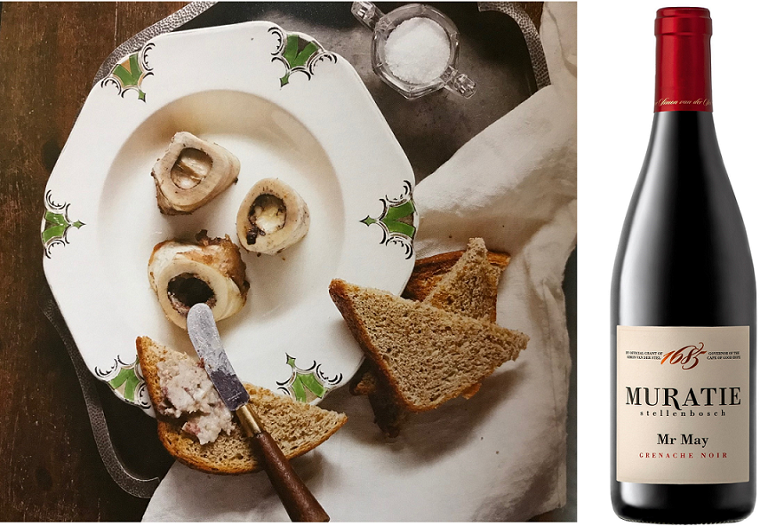

ANNATJIE MELCK’S MARROW BONES ON TOAST RECIPE

INGREDIENTS
You need the middle sections of the long bones (ask your butcher for 5cm lengths)
Salt and freshly ground black pepper to taste
Toast

METHOD
Preheat the oven to 230˚C
Rinse the marrow bones thoroughly under cold water
Dry thoroughly with kitchen paper towel
Cover an oven pan with foil and place marrow bones on top
Sprinkle salt and pepper over the bones and bake for 15-20 minutes
Marrow bones are cooked when the marrow starts pulling away from the bone and the clear fat starts to drip from the bone
Remove pan from the oven and let it cool down slightly
Use a knife to remove the marrow from the bones and spread is on toast
Add a little salt according to your liking and serve immediately

Enjoy with Muratie’s Mr May Grenache Noir!

SIP ON MURATIE WINES AND TASTE HISTORY FOR YOURSELF
Knorhoek Road, Stellenbosch · www.muratie.co.za · 021 865 2330 · info@muratie.co.za

@muratiewine  Muratie Wine Farm

