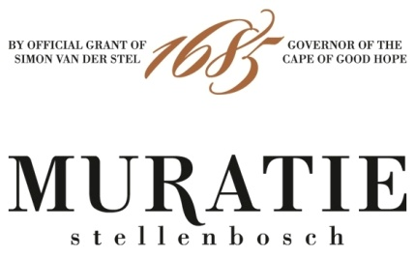

SALUTING THE CULTURE OF FOOD AND WINE AT MURATIE ESTATE

“Drinking good wine with good food in good company is one of life's most civilized pleasures”. These are the words of the late Michael Broadbent MW, legendary wine critic, writer, author and auctioneer - a towering figure in the international world of wine.

However, these could so easily be the words of Annatjie Melck, foodie legend and chatelaine of Muratie, where the culture of food and wine is an intrinsic ingredient of the Melck family’s history, and life at Muratie today.

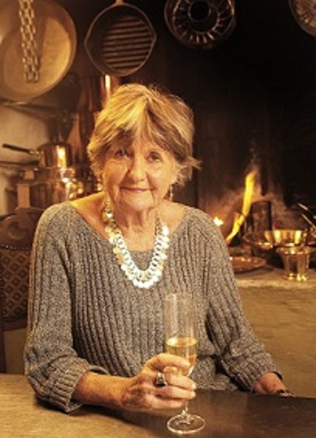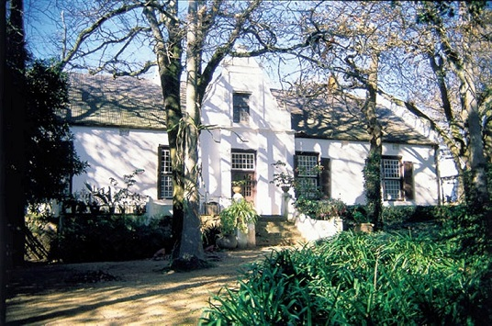

When Ronnie Melck, charismatic wine industry legend with a boundless passion for life bought Muratie in 1987, fulfilling a lifetime dream of returning the historic estate to the Melck family, he and Annatjie moved into the Muratie Manor House. “There had been so many interesting characters shaping Muratie’s past, but now it was our turn”, reminisces Annatjie. “We infused new life into the old homestead, establishing our very own culture of food and wine. There was hardly ever an empty seat at our enormous dining room table. There would be music, the wine would flow, the kitchen would be a hive of activity, and the aroma of food would infuse the atmosphere of our Muratie home. Wonderful stories were told, and friends from all over the world were made.”

Since Ronnie’s untimely passing in September 1995, Annatjie has continued to live in the Manor House and express her love of food in so many different ways. Determined to uphold the food and wine culture of Stellenbosch and the Winelands, she, together with like-minded friends, founded the Fynproewersgilde, the famous Stellenbosch Wine and Food Festival, and the iconic landmark, Oom Samie se Winkel, in Dorp Street. She also authored the highly acclaimed ‘Koljander’ where she showcases over 100 recipes interwoven with her life’s journey from the plains of the Great Karoo to Muratie. Today, Annatjie continues to work closely with her daughter-in-law Kim, also an accomplished foodie, overseeing the preparation of Muratie’s range of preserves and homemade treats available in the tasting room, and the authentic farm lunch at Muratie’s popular Farm Kitchen Restaurant. Kim describes the Farm Kitchen as an embodiment of the Melck’s food and wine culture, an extension of their home. “I have my apron on and Rijk pours the wine. We do it all and we hope for our guests that it is like being hosted in someone’s home, with warmth and friendliness.”

ANNATJIE’S RECIPES AND WINE PAIRINGS

It comes as no surprise that Annatjie has developed a treasure trove of her own very special recipes and loves to explore the very best pairings with Muratie’s wines, all of which are named after intriguing personalities intertwined with the story of the historic estate.

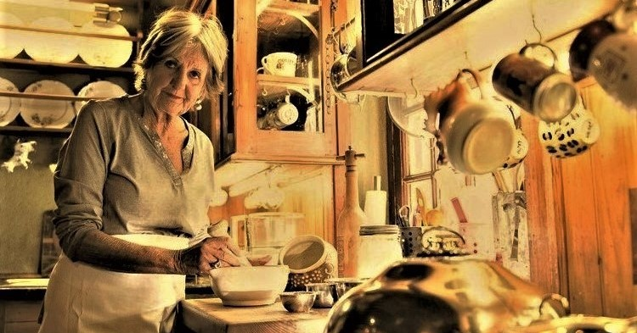

HERE ARE THREE OF ANNATJIE’S CURRENT FOOD AND WINE PAIRING FAVOURITES
The recipes and additional information on the wines is attached

ANNATJIE’S PICKLED FISH - TO SERVE WITH THE MURATIE LAURENS CAMPHER 2019

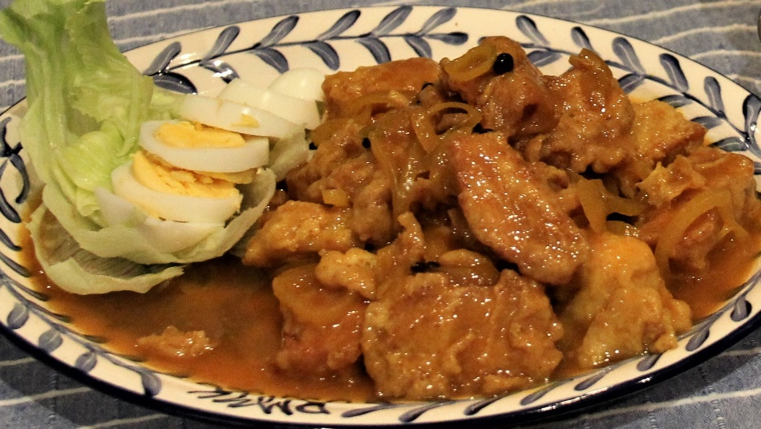

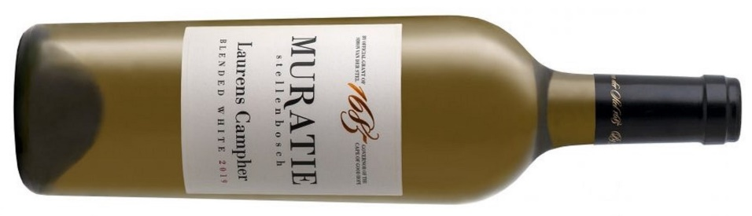

Easter time is pickled fish time, especially in the Cape, where this delicious traditional dish has been eaten for hundreds of years. Annatjie recommends that you enjoy her Pickled Fish with a glass of Muratie Laurens Campher 2019, an elegant yet intense white blend with gorgeous stone fruit flavours of peach and apricot, hints of citrus and a fresh acidity all wrapped in creamy oak. This unique judiciously oaked white blend, named in honour of Muratie’s first owner Laurens Campher - a young German soldier who fell in love with a slave-girl at the Castle in Cape Town - combines predominantly Chenin Blanc with smaller amounts of Sauvignon Blanc, Verdehlo and Viognier.

ANNATJIE’S SALMON WITH TARRAGON AND CREAM SAUCE - TO ENJOY WITH THE MURATIE ISABELLA CHARDONNAY 2019

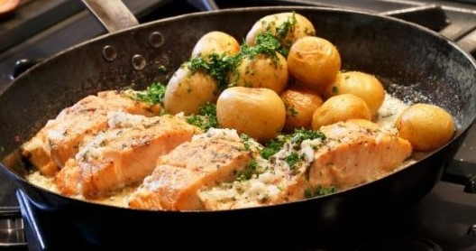

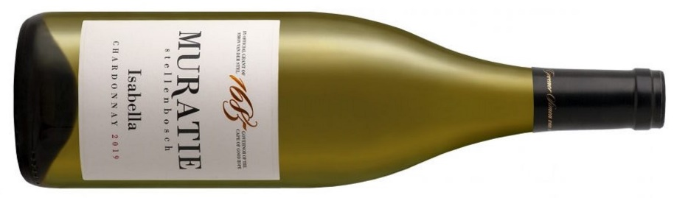
Baked in the oven, pan-fried, grilled or smoked - no matter how it is prepared, salmon is always delicious. There’s only one thing that can take the best salmon dishes to the next level: a glass of wine! And Annatjie recommends enjoying her Salmon with Tarragon & Cream Sauce with a glass of Muratie Isabella Chardonnay 2019, named in honour of her granddaughter Isabella. It is a full-bodied subtly oaked Chardonnay - with vibrant citrus notes, a smooth and rich texture, a creaminess and fresh acidity - that perfectly complements the richness of this salmon dish.
ANNATJIE’S MARROW BONES ON TOAST - TO COMPLEMENT THE MURATIE MR MAY GRENACHE NOIR 2018 (A NEW MURATIE RELEASE)

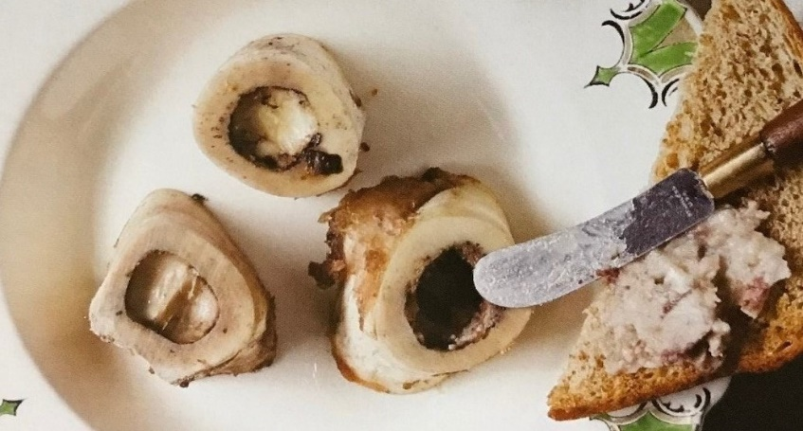

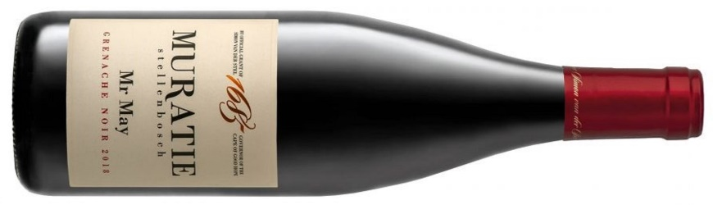

Grenache, the dominant grape in the famous red blends of Châteauneuf-du-Pape in the Southern Rhône, is one of the most versatile wines to pair with food due to its spiciness, pure red fruits and fresh attributes. Annatjie has chosen the Muratie Mr May Grenache 2018 – with its bold strawberry and raspberry notes and hints of white pepper and oak – to complement her much-loved Marrow Bones on Toast recipe. Muratie Mr May Grenache 2018 pays tribute to Cornelius, or Mr May as he was affectionately called, who planted and pruned many a vine at Muratie. His attention to detail and ability to predict the weather, long before technology, is legendary.

Muratie Wine Estate, Knorhoek Road, Stellenbosch
www.muratie.co.za · 021 865 2330 · info@muratie.co.za

@muratiewine  Muratie Wine Farm

