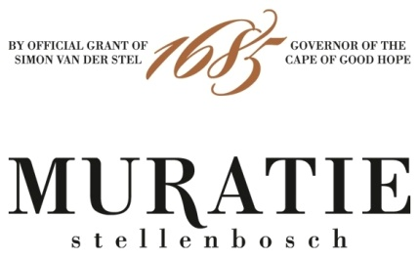

ANNATJIE’S PICKLED FISH RECIPE
PERFECTLY PAIRED WITH THE MURATIE LAURENS CAMPHER 2019

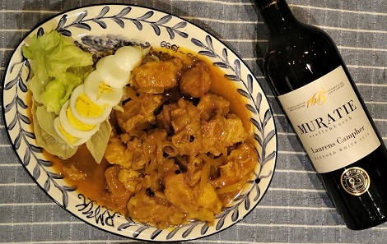

ANNATJIE’S PICKLED FISH RECIPE

INGREDIENTS
For the fish
1kg Yellow Tail or Cape Salmon (Geelbek)
45ml lemon juice
Salt and freshly ground black pepper to taste
15ml sunflower oil

For the sauce
30ml Sunflower oil
2 garlic cloves crushed
1kg onions - cut into thick rings
15ml curry powder
7,5ml turmeric
500ml vinegar - 250 ml white and 250ml brown vinegar
250ml water
125ml sugar
1x 420g canned apricots
5ml salt
2-3 slices fresh ginger
4 lemon leaves or bay leaves
2,5ml ground cumin
2,5ml ground fennel
6 whole allspice
Pinch of cayenne pepper

METHOD
For the fish
Pre heat oven to 200˚C
Fleck the fish, cut into portions and dry thoroughly with kitchen paper towel
Pour the lemon juice over the fish and season to taste
Heat the oil in an oven pan
Place the fish portions in the pan and bake for about 15 minutes until nearly done
Remove from the oven and keep warm in the warming drawer

For the sauce
Heat the oil in a heavy bottomed pot and sear the onions and garlic until the onions have become transparent
Add the curry and turmeric and fry for one minute
Add the rest of the ingredients, heat to boiling point and cook for 3 minutes

Pour the warm sauce over the warm fish in the oven pan
Let the dish cool down thoroughly (do not cover the dish)
Keep the pickled fish refrigerated for 3 days prior to serving to allow the fish to absorb all the flavours
Serve the pickled fish with salad, a hardboiled egg and a glass of Muratie Laurens Campher 2019

MURATIE LAURENS CAMPHER 2019

Every wine tells a story at Muratie, the historic Stellenbosch Estate that dates back to 1685.
The story: The Laurens Campher, Muratie’s flagship white blend pays tribute to the first owner of Muratie, the passionate and determined young German soldier who fell in love with a slave-girl at the Castle in Cape Town. During their 14-year courtship, he frequently walked the 64 kilometres to Cape Town and back, a three-day trip, to see his sweetheart Ansela. When she was eventually emancipated, Laurens and Ansela were married and Ansela and their three children joined Laurens at Muratie. The oak tree she planted to bless their marriage still stands on Muratie, as does a small white house, their first home, built for them by Laurens.
In the cellar: This uniquely South African white blend combines predominantly Chenin Blanc (54%) with smaller amounts of Sauvignon Blanc (30%), Verdelho (12%), and Viognier (4%). Components were vinified separately, barrel fermented then meticulously blended after judicious oaking in a combination of new and older 500L French Oak barrels (11 months). 40% underwent malolactic fermentation ensuring a softer acidity This blend is a labour of love, much like Laurens’ love for Ansela van de Caab.
Tasting Notes: For all its freshness, elegance and focus, the wine’s flavours are complex and intense, ranging from bright lemon, fresh pineapple, apricots and juicy nectarine to more concentrated lime marmalade as well as caramel and cream (from barrel fermentation and 11 months of maturation in mostly older French oak). On the palate the initial impression is floral (heady honeysuckle) finishing with white peaches and apricots, with hints of citrus and a fresh acidity - great persistence promising enjoyment over at least five years.

Purchase: Muratie Laurens Campher 2019 is available at the estate, online at https://www.muratie.co.za/wine/buy-wine/ and at select fine wine merchants around the country.
Approximate retail price: R190

SIP ON MURATIE WINES AND TASTE HISTORY FOR YOURSELF
Knorhoek Road, Stellenbosch · www.muratie.co.za · 021 865 2330 · info@muratie.co.za

@muratiewine  Muratie Wine Farm

