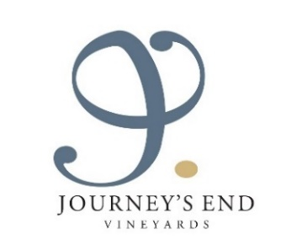
INTRODUCING JOURNEY’S END VINEYARDS’ TALES SERIES:
New Look & Vintages, ‘Tales’ from The Farm and
Some Favourite Recipes from Winemaker Mike Dawson

Journey’s End Vineyards have released the latest vintages of their new-look Tales Series; a range of four wines, each with eye-catching modern designs to show the inspiration behind the labels.

The new releases include:

Journey’s End Weather Station Sauvignon Blanc 2020
Journey’s End Haystack Chardonnay 2019
Journey’s End The Huntsman Shiraz Mourvèdre Grenache 2019
Journey’s End Pastor’s Blend Cabernet Sauvignon Merlot Cabernet Franc 2019

Winemaker Mike Dawson has kindly shared some of his favourite recipes for food pairing with the Weather Station Sauvignon Blanc and The Huntsman Shiraz Mourvèdre Grenache. Mike focuses on sustainable grape growing and winemaking with a minimal intervention approach, incorporating organic practices wherever possible. He is also mindful in his day-to-day life at Journey’s End Vineyards, which he calls home. Here, Mike grows and tends to his own bountiful vegetable and herb garden, and very much enjoys cooking seasonally with his produce.

See below Mike Dawson’s recipes for White Wine Mussel Soup to enjoy with the Weather Station, and Fillet with Peppercorn Sauce to complement The Huntsman.

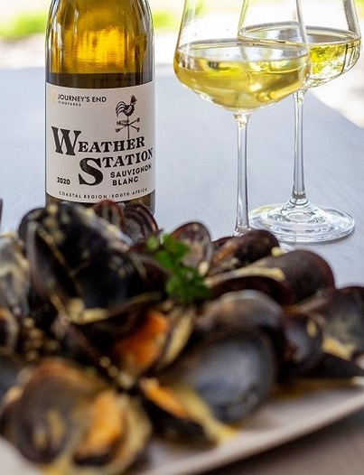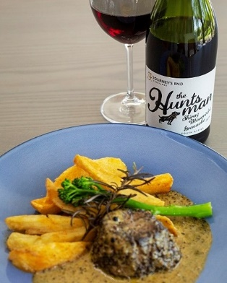

JOURNEY’S END TALES SERIES NEW VINTAGE WINES

JOURNEY’S END WEATHER STATION SAUVIGNON BLANC 2020
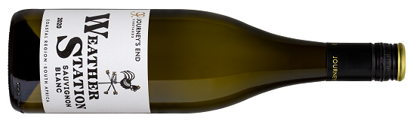
The Tale: This wine is named after the famed SB11 ‘Weerstasie Kloon’ (Weather Station clone) which is one of the core components used in this wine. First propagated in Stellenbosch in the 1920s, it made a huge resurgence in the late 1970s. The clone is nicknamed ‘The Weather Station’ as the original plantings were made beside an old weather station, which proved invaluable in enabling the farms to spot oncoming changes in the weather and thus pick their fruit at its optimum condition.
Tasting Notes: The wine displays full ripe tropical fruit notes while maintaining the fresh natural acidity and minerality distinctive of the area. A pronounced nose of passionfruit, green apple and piney notes is complemented by salty minerality, hints of kiwifruit and a seam of freshness giving vitality and extending the flavours. The wine has a lovely weight and round mouthfeel on the mid-palate, and a balanced acidity which brings freshness and length to the finish.
Food Pairing: See attached winemaker Mike Dawson’s recipe for White Wine Mussel Soup to enjoy with the Weather Station Sauvignon Blanc.

JOURNEY’S END HAYSTACK CHARDONNAY 2019 (UNOAKED)
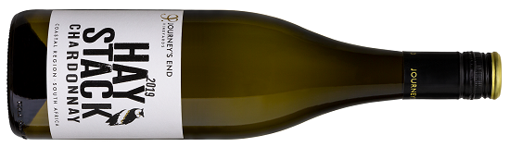
The Tale: This wine takes its name from the age-old practice of planting wheat between the rows of vines (to prevent weeds and therefore reduce the need for spraying). This is just one of a number of organic and bio-dynamic practices on the farm. This wine pays homage to the preservation and protection of nature and the environment at Journey’s End.
Tasting notes: Pronounced citrus peel, lime and melon flavours delight on the nose and the palate, enhanced by a richness and complexity from 4 months post fermentation lees contact. Drink now and up until 2023. The balance between creaminess and freshness makes for a food-friendly wine.
Food Pairing: Ideal with sushi, creamy dishes and seafood.

JOURNEY’S END THE HUNTSMAN - SHIRAZ MOURVÈDRE GRENACHE 2019
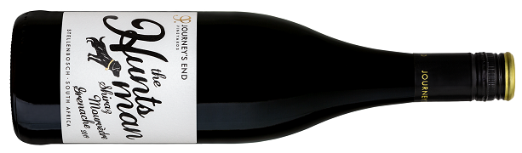
The Tale: This wine is named in honour of the Cape Hunt hounds’ original kennels dating back to 1822, the foundations of which were found by the Gabb family when they were building their cellar. 1811 marked the first ever hunt in the Western Cape with hounds imported from Gloucestershire, UK. To this day, the Cape Hunt remains the oldest Hunt in the New World.
The Blend: 54% Shiraz, 20% Mourvèdre, 20% Grenache with 6% Viognier
Tasting Notes: A beautiful dark ruby red colour, this wine shows expressive notes of violets, redcurrant and cherries with hints of white pepper and liquorice along with an evenly balanced oak structure and elegant soft powdery tannins. It is full bodied and smoothly luscious, the freshness adding lift and vibrancy to the richness of the dark fruit. Drink now and until 2024.
Food Pairing: See attached winemaker Mike Dawson’s recipe for Fillet with Peppercorn Sauce to complement The Huntsman.

JOURNEY’S END PASTOR’S BLEND - CABERNET SAUVIGNON MERLOT CABERNET FRANC 2019
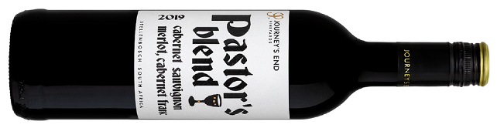
The Tale: This wine pays homage to the Pastors from the local village of Sir Lowry’s Pass who regularly deliver Sunday sermons at the foot of the Journey’s End vineyard. It is through these local pastors that Journey’s End channels resources for their support and development programmes to uplift a community traditionally plagued by low socio-economic conditions. Journey’s End’s support includes running soup kitchens and pensioners lunches, building a new school hall, providing music lessons, funding a creche and a campaign to eradicate bullying in the township schools.
The Blend: 44% Cabernet Sauvignon, 29% Merlot, 27% Cabernet Franc
Tasting Notes: A well-judged partnership of the classic Bordeaux varieties, this is an elegant harmonious wine displaying rich notes of juicy dark red fruit including plums, cherries and blackberries with a savoury spice dusting from the oak and some dried herbs giving it versatility for a range of food dishes. This wine is made for earlier drinking rather than long cellaring.
Food Pairing: Enjoy with lamb shanks, roast beef or venison.

PURCHASE JOURNEY’S END TALES SERIES WINES

All four of the Tales Series wines are vegan-friendly and are available for purchase at the cellar, online at https://shop.journeysend.co.za/ and nationally at selected retail outlets and wine merchants. Approximate retail prices: R100 for the white wines and R117 for the red wines.

JOURNEY’S END V SERIES AND PRECISION SERIES WINES

Journey’s End Vineyards’ other wines include the V Series and Precision Series:
V Series: five varietal wines - Chardonnay, Merlot, Shiraz, Cabernet Sauvignon and Cabernet Franc retailing between R177 and R198.
Precision Series: three top tier wines - Destination Chardonnay, Cape Doctor (Cabernet Sauvignon) and The Griffin (Syrah), retailing at approximately R300.

MORE ABOUT JOURNEY’S END VINEYARDS

Terroir, Vineyards, Cellar and Wines

Journey’s End Vineyards is a boutique estate situated on the south-west facing slopes of the famous Schapenberg Hills above Sir Lowry’s Pass Village in the Helderberg basin. The picturesque farm with excellent terroir was purchased by the Gabb Family originally from Shropshire, UK in 1995, with a focus on ethically and sustainably producing wines of excellence.

Situated on the south-west facing slopes of the famous Schapenberg Hills, the vineyards, which have ancient 350-million-year-old decomposed granite soils, overlook the nearby False Bay. As well as fantastic views, the vineyards benefit from the cooling and cleansing powerful south-easterly wind, known as the ‘Cape Doctor’, which blows in from the icy Atlantic Ocean.

The very modern cellar provides cellar master Leon Esterhuizen and winemaker Mike Dawson with all they need to produce the highest-quality wines. Innovative and progressive, the team uses processes such as carbonic maceration, push boundaries with amphorae pots and concrete eggs and have adopted a philosophy of minimal intervention, both in the cellar and in the vineyards.

A commitment to excellence has seen Journey’s End wines winning multiple prestigious awards over the years, both locally and abroad.

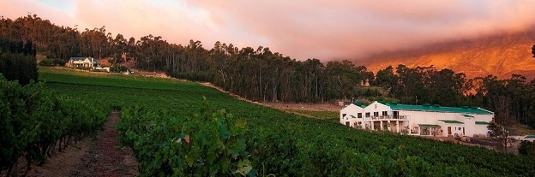

Sustainable Farming, Conservation and Social Responsibility

There has always been a deep respect for the environment at Journey’s End, with a dedication to regenerative farming practices, conserving previously unprotected natural systems, promoting biodiversity and the efficient use and management of water and energy. Journey’s End were the 2nd wine producer in SA to convert to solar energy in 2014. This long-term commitment to farming in harmony with nature saw Journey’s End awarded WWF (World Wide Fund for Nature) Conservation Champion Status in 2020, a prestigious accreditation bestowed upon environmental leaders in the Cape Winelands.

Rollo Gabb, managing director says, “We are fortunate that our unique micro-climate created by the mountains, sea and wind allows for the implementation of biodynamic farming principles, with the powerful ‘Cape Doctor’ wind cleansing our vineyards of fungal diseases and pests. We plant lupins and wheat between the rows of vines to inhibit weed growth and thus avoid the need for chemical spraying. Journey’s End has over 40 beehives on the farm that encourage pollination, promote biodiversity, and provide delicious honey. The presence of bees on a farm also indicates a healthy and clean vineyard. The introduction of Egyptian Geese (to control snail populations) and a resident pair of Spotted Eagle Owls (to control rodents) and the use of natural pesticides all play their part in ensuring that the environment is preserved and protected.”

Journey’s End’s dedicated focus - on high quality wines, sustainable farming and conservation - extends to the local community in Sir Lowry’s Pass. Rollo continues, “Making a positive impact on the environment and on the well-being of our community is at the centre of our beliefs. In August 2020, we launched the Journey’s End Foundation community project to tackle hunger and extreme poverty in the Helderberg Region through a network of soup kitchens – largely as a result of Covid-19.”

This extraordinary commitment led to Journey’s End being awarded ‘Ethical Company of the Year’ at The Drinks Business Green Awards 2020. These awards are dedicated exclusively to green-minded drinks companies, celebrating the eco-conscious and ethical, and drawing attention to green leaders who are benefitting their surroundings socially, ethically, and environmentally.

The Journey’s End Foundation recently surpassed the remarkable milestone of providing 500,000 meals to their local community and is aiming to serve up one million meals by the end of 2021.

Rollo Gabb concludes: “We believe in drinking well, while truly being a force for good. We will continue our focus on benefitting our surroundings environmentally, socially and ethically to ensure that we leave a legacy for generations to come.”
JOURNEY’S END ACCREDITATIONS

The Journey’s End team has always been wholly committed to being environmentally sustainable and socially responsible – a dedication that seen the farm steadily picking up numerous admirable accreditations over the years.

- WIETA (Wine and Agricultural Industry Ethical Trade Association) accredited since 2013
- HACCP (Hazard Analysis and Critical Control Point) accredited since 2014
- BWI (Biodiversity and Wine Initiative) accredited since 2013
- IPW (Integrated Production of Wine) accredited since 2013. IPW is a voluntary environmental sustainability scheme
- Fairtrade accreditation since April 2017 - and now working towards ISO 22000
- IFS (International Featured Standards) accredited since February 2019
- WWF (World Wide Fund for Nature) Conservation Champion 2021

VISIT JOURNEY’S END VINEYARDS

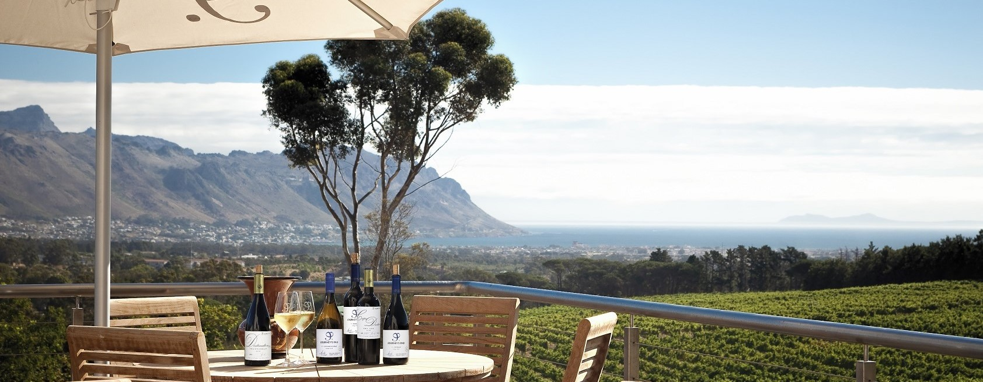

The stylish tasting centre, glassed on three sides, overlooks the barrel cellar and embraces the untrammelled beauty of the panoramic vista. The décor is elegantly minimalist and chic, and the centre spills out onto a spacious terrace, offering spectacular views of mountains, vineyards and False Bay, all the way across to Cape Point.

- Tasting and sales by appointment: Monday Friday: 10h00 - 17h00
- BYO picnic, walks, hikes, MTB and horse-riding
- The floating lapa on the dam is also very popular for tastings, sundowners, swimming, fishing and stargazing
- Journey’s End’s magnificent Trebuchet is not to be missed!

The Journey’s End Trebuchet

Journey’s End’s magnificent Trebuchet is not to be missed. You’ll battle not to have fun at Journey’s End watching their 42-foot tall, 12-ton medieval siege weapon in action – hurling missiles across the field and providing great excitement and entertainment. While the Trebuchet is a grand attraction for visitors, it also provides a huge amount of excitement for the local community of Sir Lowry’s Pass Village and is used to raise funds for Journey’s End’s Community Project. Follow the link below for more info and to see the Trebuchet in action!
http://www.journeysend.co.za/our-trebuchet/

JOURNEY’S END VINEYARDS, SIR LOWRY’S PASS ROAD, SOMERSET WEST 7130
Tel: 021 858 1929 · Email: info@journeysend.co.za
Website: http://www.journeysend.co.za/ · Facebook: https://www.facebook.com/journeysendwines
Twitter: https://twitter.com/JourneysEndWine · Instagram: https://www.instagram.com/journeysendwines/

