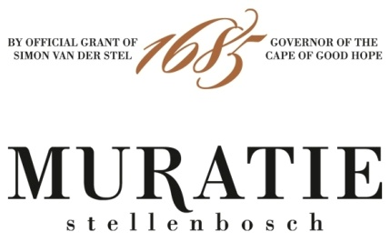

ANNATJIE’S SALMON WITH TARRAGON AND CREAM SAUCE
PERFECTLY PAIRED WITH THE MURATIE ISABELLA CHARDONNAY 2019

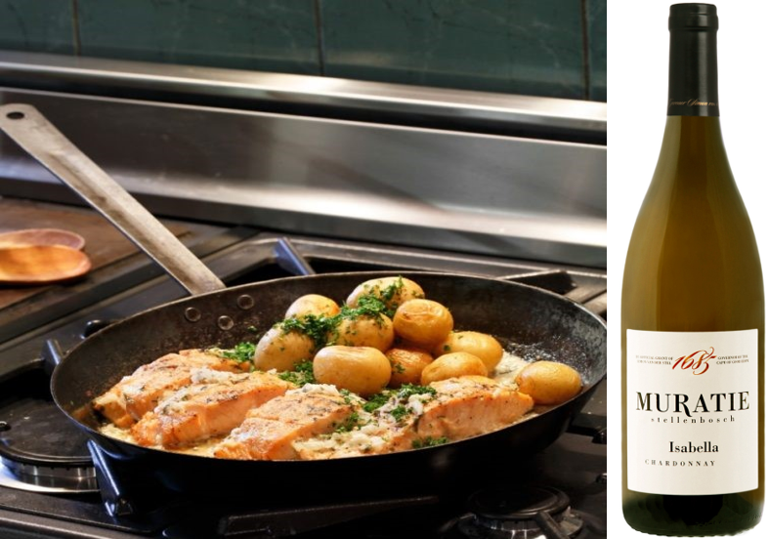

ANNATJIE’S SALMON WITH TARRAGON AND CREAM SAUCE RECIPE

INGREDIENTS
2 Salmon fillets
Salt and freshly ground pepper to taste
1 Tbsp (15ml) sunflower oil
½ Small onion, finely chopped
2 Tbsp (30ml) fresh tarragon, finely chopped
4 Tbsp (90ml) thick cream
2 Tbsp (30ml) fresh parsley, finely chopped

METHOD
Preheat the oven to 160˚C
Season the salmon on both sides with salt and pepper
Heat the oil in a heavy-duty pan until hot and cook the salmon (skin side up) for 3 minutes until light brown, then turn it over and cook on the skin side for 2 minutes
Place the salmon in an oven safe dish and sprinkle the onion and the tarragon over the fish
Add the cream to the dish and bake for 10-12 minutes until the salmon is cooked
Sprinkle parsley over the dish and serve with boiled baby potatoes
Enjoy with the Muratie Isabella Chardonnay 2019

MURATIE ISABELLA CHARDONNAY 2019

Every wine tells a story at Muratie, the historic Stellenbosch Estate that dates back to 1685.

The story: For Rijk and Kim Melck, there could be only one name for their Burgundian-style Chardonnay, the name of their first child, Isabella, who today, as a young woman, is classic and elegant just like the Chardonnay.
In the cellar: The Isabella Chardonnay 2019 was made from the free-run juice of hand-harvested, whole-bunch pressed grapes, and barrel fermented (40% wild fermentation). 60% underwent malolactic fermentation. The wine matured for 9 months in 500L French oak barrels (30% new).
Tasting notes: A beautifully fresh, understated and elegant Chardonnay with an enticing peach-blossom fragrance, ripe stone fruit, melon and citrus flavours with hints of hazelnuts and vanilla cream from subtle oaking, and a lingering mineral finish.

Purchase: Muratie Isabella Chardonnay 2019 is available at the estate, online at https://www.muratie.co.za/wine/buy-wine/ and at select fine wine merchants around the country.
Approximate retail price: R220???

SIP ON MURATIE WINES AND TASTE HISTORY FOR YOURSELF
Knorhoek Road, Stellenbosch · www.muratie.co.za · 021 865 2330 · info@muratie.co.za

@muratiewine  Muratie Wine Farm

