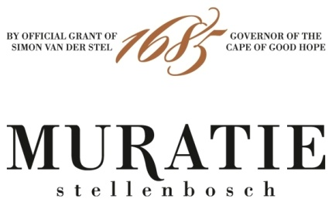

ANNATJIE’S MARROW BONES ON TOAST RECIPE
PERFECTLY PAIRED WITH THE MURATIE MR MAY GRENACHE NOIR 2018

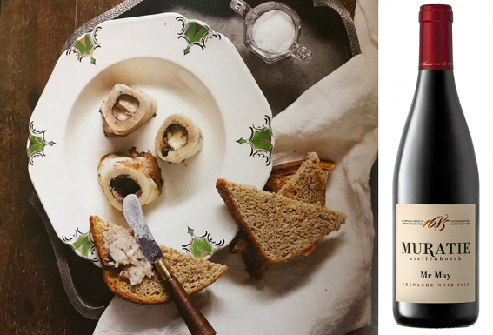

ANNATJIE’S MARROW BONES ON TOAST RECIPE

INGREDIENTS
You need the middle sections of the long bones (ask your butcher for 5cm lengths)
Salt and freshly ground black pepper to taste
Toast

METHOD
Preheat the oven to 230˚C
Rinse the marrow bones thoroughly under cold water
Dry thoroughly with kitchen paper towel
Cover an oven pan with foil and place marrow bones on top
Sprinkle salt and pepper over the bones and bake for 15-20 minutes
Marrow bones are cooked when the marrow starts pulling away from the bone and the clear fat starts to drip from the bone
Remove pan from the oven and let it cool down slightly
Use a knife to remove the marrow from the bones and spread is on toast
Add a little salt according to your liking and serve immediately
Enjoy with Muratie’s Mr May Grenache Noir

MURATIE MR MAY GRENACHE NOIR 2018
(A NEW MURATIE RELEASE)

Every wine tells a story at Muratie, the historic Stellenbosch Estate that dates back to 1685.

The story: Cornelius, or Mr May as he was affectionately called, planted and pruned many a vine at Muratie Wine Estate “His attention to detail and ability to predict the weather, long before technology, is legendary. He taught us that whenever we saw a silver cloud lying on the South West facing side of Simonsberg Mountain, it would rain in two days' time. Today still, in memoriam, we have yet to prove him wrong”, says Rijk Melck.
In the vineyard and the cellar: Low-yielding dryland vines planted at 368m above sea level produce fruit with a high intensity of flavours. The grapes were fermented in half ton stainless steel open fermenters. Half of the batch underwent spontaneous whole berry fermentation. The wine was then basket pressed and taken to barrel for malolactic fermentation. It was aged for 18 months in 500L French Oak barrels.
Tasting notes: The nose shows ample red fruit, especially strawberries, with hints of fynbos and spice and some floral notes. The palate is fruit forward with loads of raspberries and a punch of pomegranate rubies, complemented by a savoury earthiness and subtle white pepper spice notes. The wine has a lovely freshness and length with a hint of cranberry on the finish.

Purchase: Muratie Mr May Grenache Noir 2018, a new addition to the Muratie range of wines, is only available at the estate and online at https://www.muratie.co.za/wine/buy-wine/.
Approximate retail price: R220???

SIP ON MURATIE WINES AND TASTE HISTORY FOR YOURSELF
Knorhoek Road, Stellenbosch · www.muratie.co.za · 021 865 2330 · info@muratie.co.za

@muratiewine  Muratie Wine Farm

