
SEAFOOD SPAGHETTI WITH FAT bastard CHENIN BLANC

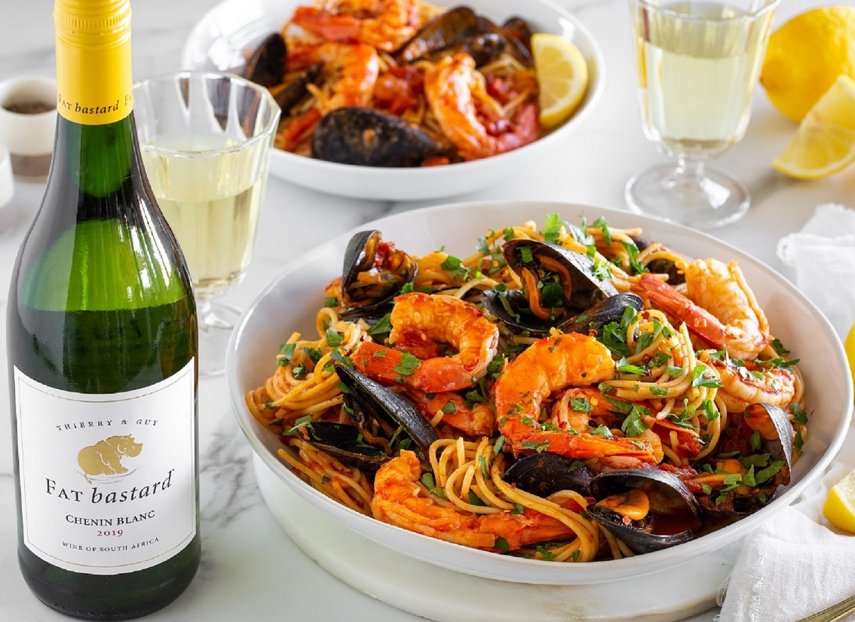

SERVES 6-8

INGREDIENTS:
- 1 onion, finely diced
- 4 garlic cloves, finely sliced
- 1 tsp chilli flakes (or more to taste)
- 3 Tbsp tomato paste
- 200ml FAT bastard Chenin Blanc
- 800g whole Italian tinned tomatoes
- 500g spaghetti
- 1kg mussels, scrubbed & debearded
- 1kg king prawns / giant tiger prawns, peeled & deveined but keep the tail on
- 4 Tbsp butter, cubed
- 3 Tbsp parsley, chopped
- Juice & zest of 1 lemon
- Lemon wedges, for serving
- Salt and pepper, to taste
- Extra-virgin olive oil

METHOD:
- Heat a generous drizzle of olive oil in a very large pot over medium.
(You want to be able to combine all elements of the dish in one pot at the end so use a ±26-30cm dutch oven)
- Cook onion with a pinch of salt until lightly golden and soft.
Add garlic and chilli flakes and cook until fragrant.
Add tomato paste and cook for a few minutes until the colour darkens to a rich brick red.
Pour in the FAT bastard Chenin Blanc and deglaze the pot well.
Stir until the smell of the alcohol is gone and the wine reduces slightly.
- Pour whole tinned tomatoes and their juice into a bowl and crush them with your hands into uneven juicy little pieces.
- Add crushed tomatoes and their juices to the pot.
Bring everything to a simmer. Simmer until the sauce thickens and season to taste.
- Meanwhile- cook spaghetti in a large pot of boiling salted water. Cook until very al dente.
The pasta will continue to cook in the sauce so it should still have a lot of bite to it.
Scoop out and reserve 1 cup of pasta water. Drain the pasta.
- Add cleaned mussels and prawns to the tomato sauce, layering the prawns on top as they are the most delicate. If you need a bit more liquid to cook the seafood pour in a dash of pasta water. Cover with a lid and cook for a few minutes, shaking the pot until the mussels open. Using tongs, remove mussels and prawns and set aside in a bowl.
Discard any mussels that have not opened.
- Add the undercooked spaghetti and butter to the pot.
Reduce heat to medium, and stir gently, adding more pasta water if needed.
Stir until the sauce coats the pasta and the pasta is cooked.
Remove from the heat, return prawns and mussels to pot, and gently toss to combine.
Mix in parsley, lemon zest and lemon juice.
- Serve pasta with lemon wedges for squeezing over, a simple salad and some crusty bread for mopping up the sauce.
- ENJOY WITH A GLASS OF THE GORGEOUS FAT bastard CHENIN BLANC: Sumptuous and complex with intense fruit flavours, juicy yellow peach and a hint of vanilla dance across the palate and the wine lingers with a tangy note of fresh lime on the finish. A perfect accompaniment to Seafood Spaghetti.

The FAT bastard Chenin Blanc can be purchased online at https://shop.fatbastardwine.co.za/ and is widely available nationally, retailing at around R95.
Website: http://www.fatbastardwine.co.za/
Facebook: https://www.facebook.com/FATbastardWineSA/
Twitter @FATbastardSA · Instagram @FATbastardSA
Hashtag #LiveLARGE

Issued on behalf of the Robertson Winery by: | Robertson Winery
Posy & Jeremy Hazell PR & Social Media Consultants | Contact: Riekie Viljoen
Cell; 082 557 2968 | Tel: 021 883 8043
Email: posy@hazell.co.za | Email: riekie@robertsonwinery.co.za

