

JOURNEY’S END’S WINEMAKER, MIKE DAWSON, SHARES HIS FILLET WITH PEPPERCORN SAUCE RECIPE
TO BE ENJOYED WITH JOURNEY’S END THE HUNTSMAN SHIRAZ MOURVÈDRE GRENACHE

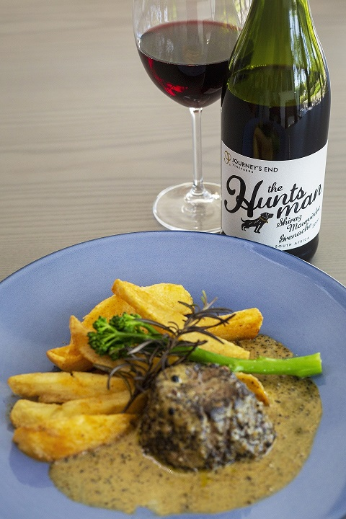

Mike’s comments on The Huntsman pairing with his Fillet with Peppercorn Sauce recipe
“Our Rhône-styled red blend is predominantly driven by Shiraz, which brings with it an ever-evident white pepper spice. The blend is rounded by Mourvèdre (which adds a nice savoury character) and Grenache (which brings beautiful red fruit to the blend). This wine perfectly complements a beautiful rich red meat dish on a cold winter’s day and is also a perfect choice for a casual hot summer’s day when chilled down to 14 degrees. It certainly won’t disappoint. It is a wine to be enjoyed on all occasions!”

FILLET WITH PEPPERCORN SAUCE RECIPE

Ingredients

- 1 tbsp vegetable oil
- 25g clarified butter
- 2 fillet steaks (ideally beef matured for 3-5 weeks), about 140g/5oz each, at room temperature
- A knob of butter
- 2 large shallots, finely chopped (from my garden)
- 6 medium mushrooms, sliced (from my garden)
- 2 tsp green and pink peppercorns, crushed (from my garden)
- 3 tbsp brandy
- 100ml Journey’s End “The Huntsman” (We use a bit more than that)
- 200ml good-quality beef stock
- 3 tbsp double cream

Method

- Heat a frying pan over a medium-to-high heat, then pour in the oil and the clarified butter. Add the steaks, season them with salt and plenty of freshly ground black pepper and cook to your liking (2 mins each side for medium-rare, 3 mins each side for medium, depending on the thickness of your steaks). Be sure to seal the rounded edges, too. Transfer to a plate.
- Add the knob of butter to the pan, then fry the shallots, mushrooms, and peppercorns over a medium heat for 5 mins, until the shallots have softened, and the mushrooms have browned. Return the steaks to the pan. Heat the brandy in a metal ladle, light with a match then carefully pour into the hot pan, standing as far back as you can. Once the pan has stopped flaming, remove the steaks again.
- Pour the wine into the pan, turn up the heat and boil rapidly until reduced by half. This will take about 5 mins. Add the stock and reduce again, this time by two-thirds. Stir the cream into the sauce and allow it to thicken slightly. Check the sauce for seasoning, then return the fillets to the pan to warm through, spooning the sauce over. Serve straight away.

ENJOY WITH JOURNEY’S END “THE HUNTSMAN SHIRAZ MOURVÈDRE GRENACHE”

