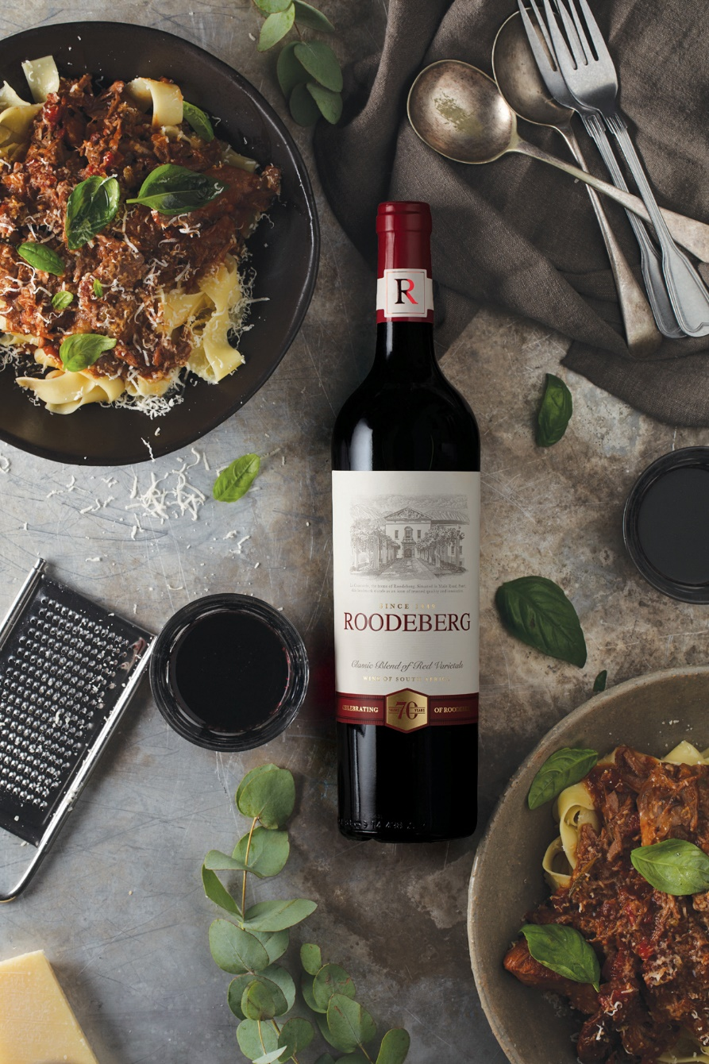
Spoil dad with Roodeberg’s hearty slow cooked lamb shank ragu
Indulge the whole family on Father’s Day with a rich and hearty Roodeberg slow cooked lamb shank ragu accompanied by this trusty South African red that gets better with age just like your dad.
Opulent and meaty, this recipe is Roodeberg’s take on the traditional Italian slow cooked meat sauce enjoyed with pasta.
The full flavour of the lamb shank is intensified when braised slowly in Roodeberg wine, leaving it tender enough to shred into a nourishing, winter warming pasta sauce.
Nothing says "thanks dad" like reminiscing over a glass or two of Roodeberg while tucking into tasty winter comfort food.
Roodeberg Classic Red 2019 is a fine match for this slow cooked lamb ragu. The wine erupts in your glass with aromatic layers of red and dark fruit, cassis and hints of sweet spice and dark chocolate. The palate is elegant and well-rounded with nuances of cedar oak and dark plums, supported by elegant silky tannins that linger long after the last sip.
Roodeberg’s slow cooked lamb shank ragu recipe
Served on pappardelle pasta and garnished with fresh basil and pecorino shavings
Ingredients
1 kg lamb shanks or boneless lamb shoulder or leg cut into large cubes
60 ml seasoned flour
olive oil
125 g streaky bacon, diced
1 onion, chopped
1 stalk of celery, diced
1 large carrot, diced
125 ml Roodeberg Red wine
15 ml beef stock concentrate
Rosemary
3 garlic cloves
1 can chopped tomatoes
2 bay leaves
To serve: Pappardelle (cooked when ready to serve and tossed in olive oil) and fresh basil leaves
Method
Dust lamb shanks with seasoned flour. Heat oil in a large oven proof dish and brown the meat on all sides. Set lamb aside. In the same dish, sauté the bacon first, then add the onion, celery and carrot and simmer until glossy.
Add Roodeberg red wine, stock concentrate, chopped tomatoes, rosemary, garlic and bay leaves. Simmer for 2 minutes. Add lamb back into the pot. Spoon the mixture over the lamb shanks. Cover and roast at 160°C for ± 3 hours.
Use 2 forks to pull the meat away from the bone and combine well with the mixture in the pot. Remove bones. Simmer on the stove for a few minutes and season to taste.
Serve on pappardelle and finish off with fresh basil leaves and pecorino shavings.

________________________________________________________________________
Issued by: GC Communications Contact: Gudrun Clark
Tel: 021-4620520 Email: gudrun@g-com.co.za
On behalf of: Roodeberg Contact: Carli Jordaan

