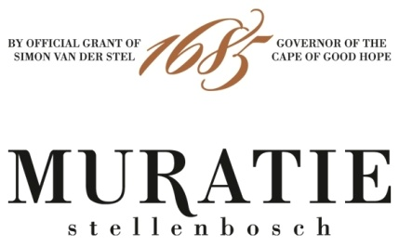

CELEBRATE #MERLOTDAY WITH MURATIE ALBERTA ANNEMARIE CANITZ MERLOT

PERFECTLY PAIRED WITH ANNATJIE MELCK’S MUSHROOM RISOTTO

It is International Merlot Day on 7th November, so raise a toast to this popular noble grape - the hands-down crowd-pleaser of the wine world - with its luscious dark and red fruit notes, soft, sensual, velvety texture and approachable style – which also happens to be one of the most food-friendly wines on the market.

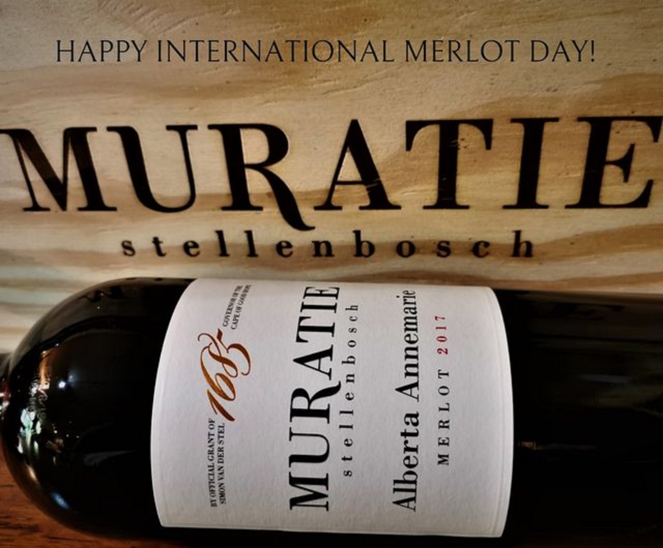

Muratie invites you to celebrate #MerlotDay, exploring the many delights of the Muratie Alberta Annemarie Canitz Merlot 2017, honouring one of the original female pioneers in the wine industry who helped mould Muratie as we know it today.

And in true Muratie style, where the culture of food and wine is an intrinsic ingredient of the Melck family’s history, and life at Muratie today, Annatjie Melck, foodie legend and chatelaine of Muratie, has provided her much-loved Mushroom Risotto recipe for a perfect pairing with Muratie’s Alberta Annemarie Canitz Merlot 2017.
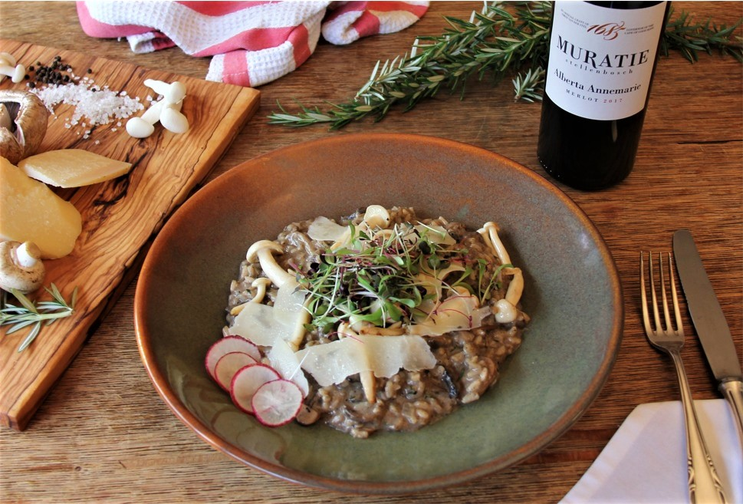

MURATIE ALBERTA ANNEMARIE CANITZ MERLOT 2017

Winemaker’s Notes: Handpicked from three low yielding 27-year-old dryland vineyard blocks situated at 280m above sea level, the grapes were crushed, destalked and pumped into traditional concrete open fermenters and matured in French oak barrels for 12 months.

Muratie’s Alberta Annemarie Canitz Merlot 2017 has all the hallmarks of a classic Merlot with ripe plums and earthy notes supported by a core of minerality and fleshed out with luscious dark berry fruit and notes of cocoa, cinnamon, oak spice and toasted hazelnuts. Its full-bodied richness is balanced by fresh acidity and a pinch of mixed herbs. Made in a soft and approachable style for early enjoyment, it nonetheless has enough backbone and plenty of length on the finish to suggest that it won’t disappoint those who wish to cellar it for 5 years.

The Story: “As is our motto at Muratie, all our wines are named after the remarkable personalities from our rich, centuries-old heritage. When you sip on our wines you are tasting history for yourself,” says Rijk Melck. “Our Merlot honours Alberta Annemarie Canitz (fondly known as Annemie), a feisty pioneer who became one of the first female wine farm owners in the country. “

It all began in 1926 when Annemie and her father, famous German artist and bon vivant George Paul Canitz, were out horseback riding when they happened upon an old, neglected manor house, under beautiful old oak trees, which had sadly fallen into disrepair. They both fell instantly in love with the charm of the place and bought it, making it their mission to renovate and replant the old farm and restore it to its former grandeur.

At Muratie George Paul Canitz did what he loved best: winemaking, painting, horse-riding and hosting merry parties. His greatest fame came from being the first ever Pinot Noir producer in the country, with the help of prominent viticulturist, Professor Abraham Perold (who created Pinotage). “Honouring George Paul Canitz’s contribution to the wine industry, we renamed our Pinot Noir the Muratie George Paul Canitz Pinot Noir,” Rijk continues.

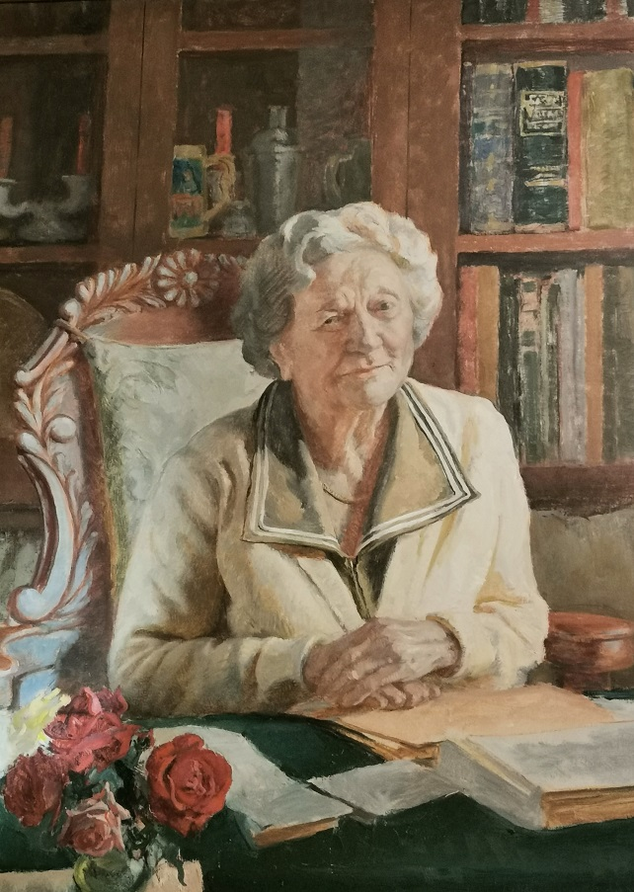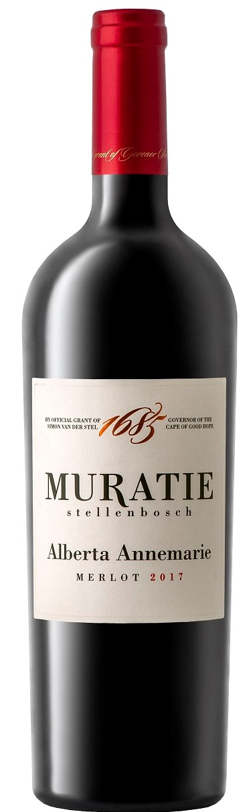

Sharing George Paul Canitz’s devotion to all things Muratie and having lived on the farm for more than 30 years assisting her father, it was Annemie who inherited Muratie when he died in 1958. Strong and independent, she ran the farm competently on her own for almost 30 years with the help of winemaker Ben Prins, the barefoot winemaker, after whom Muratie’s Cape Vintage is named. Fiercely protective of Muratie’s legacy, she honoured the estate with love and passion, keeping everything exactly the way it was in her father’s time - the cellar, the manor house, the art studio he built from bricks made on the farm, and his famous ‘kneipzimmer’ (drinking den) - everything is still very much the same today. Following in fer father’s footsteps, Annemie continued to make wine and ride her horse well into her 80s, eventually only stopping, she insisted, ‘because the horse is too old.’

At the advanced age of 87 and having no descendants, Annemie was looking for suitable successor, and no one was more perfect than Ronnie Melck. A direct descendant of the legendary Martin Melck (who together with his descendants, owned Muratie for 134 years), Ronnie had nurtured a 30-year-long dream of returning Muratie to the Melck fold. He had first come across the enchanting historic estate and its charismatic owner, George Canitz, as a student buying wine for his ‘koshuis’ dance. After George’s death, Ronnie visited Annemie on many occasions to procure her much sought-after grapes for Stellenbosch Farmers Winery (the country’s largest wine and spirit company at the time). Annemie was so taken with Ronnie that 37 years later, in 1987, it was Ronnie she phoned to offer him Muratie, knowing her beloved Muratie would be in the right hands. The sale was sealed with a promise that Ronnie would keep Muratie exactly as it was at the time. Thanks to the Melck family’s passionate guardianship, this memorable legacy lives on at Muratie, where time has largely stood still, where the unique old-world ambience is almost tangible.

Purchase: The Muratie Alberta Annemarie Merlot 2017 is available at the estate, online at https://www.muratie.co.za/wine/buy-wine/ and at select fine wine merchants around the country.
Approximate retail price: R180

Food Pairing: The earthy notes in Muratie’s Merlot make for a delicious pairing with Annatjie Melck’s Mushroom Risotto, bringing out the umami notes in both the wine and risotto. SEE RECIPE BELOW.

ANNATJIE MELCK’S MUSHROOM RISOTTO RECIPE
SERVES 4

INGREDIENTS
- 20g dried porcini mushrooms
- 1 litre vegetable or chicken stock
- 2 tablespoons olive oil
- 1 tablespoon butter
- 1 small onion, finely chopped
- 2 garlic cloves, crushed
- 375g risotto rice (arborio, vialone, nano or carnaroli)
- 250g mushrooms, sliced
- Pinch of nutmeg
- 45g Parmesan, grated
- 3 tablespoons finely chopped parsley

METHOD
SOAK the porcini in 500ml boiling water for 30 minutes. Drain, retaining the liquid. Chop the porcini mushrooms and pass the liquid through a fine sieve. Put the stock in a saucepan, bring to the boil and then maintain at a low simmer.

HEAT the olive oil and butter in a Iarge wide heavy-based saucepan. Cook the onion and garlic until softened but not browned. Add the rice and reduce the heat to 1ow. Season and stir briefly to thoroughly coat the rice. Toss in the fresh mushrooms and nutmeg. Season and cook, stirring, for 1-2 minutes. Add the porcini and their liquid, increase the heat and cook until the liquid has been absorbed.

STIR IN a ladleful of stock and cook over moderate heat, stirring continuously. When the stock has been absorbed, stir in another ladleful. Continue like this for about 20 minutes, until all the stock has been added and the rice is al dente. (You may not need to use all the stock, or you may need a little extra.) Remove from the heat and stir in the Parmesan and parsley. Season and serve.

ENJOY with a glass of Muratie Alberta Annemarie Merlot 2017!

A VISIT TO MURATIE

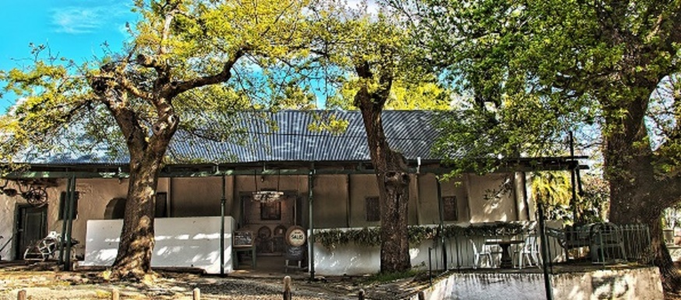
Muratie’s rich heritage is reason enough to pay a visit to this historic farm, but there’s also an abundance of events and activities at the estate that keep visitors returning.
- Wine tasting and wine and chocolate pairings in the enchanting tasting room
- Authentic farm breakfasts and lunches at the Muratie Farm Kitchen
- Wine, food and music festivals for the whole family
- Amazing trails/events for mountain biking, trail running and hiking including a brand-new trail centre
- Exhibitions of contemporary art and culture at the MOK Gallery located in Ansela van de Caab’s house
- Accommodation in George Paul Canitz’s original art studio
- Event curation in an exquisite marquee with panoramic views, or on Muratie’s verdant terraces beneath the ancient oak trees. The Muratie Canvas offers a stylish blank slate to create the event of a lifetime.

SIP ON MURATIE WINES AND TASTE HISTORY FOR YOURSELF
Knorhoek Road, Stellenbosch · www.muratie.co.za · 021 865 2330 · info@muratie.co.za

@muratiewine  Muratie Wine Farm

