

A FESTIVE SEASON FEAST FROM GEORGIA EAST
AND KRONE VINTAGE-ONLY CAP CLASSIQUE

Sustainably Sourced Crayfish Risotto with Paprika Browned Butter
To Enjoy with Krone Vintage Rosé Cuvée Brut

Georgia East, highly respected cook, writer, food stylist, photographer and author of West Coast Wander and her beautiful blog East Afternoon, has shared her delicious recipe for Crayfish Risotto.

“Sustainably sourced crayfish bathed in a rich paprika browned butter adds a hint of spice to plump arborio rice simmered in homemade seafood stock. Pairing the risotto with Krone Vintage Rosé Cuvée Brut brings out the crayfish’s delicate flavour – the Cap Classique is used both in as well as to pair with the final dish.” says Georgia.

“Use sustainably harvested West Coast Rock Lobster (Jasus lalandii) or opt for farmed crayfish tails. Equally as delicious when using fresh or frozen crayfish. Cooking up a speedy stock using the crayfish shells, celery and shallots makes all the difference.”

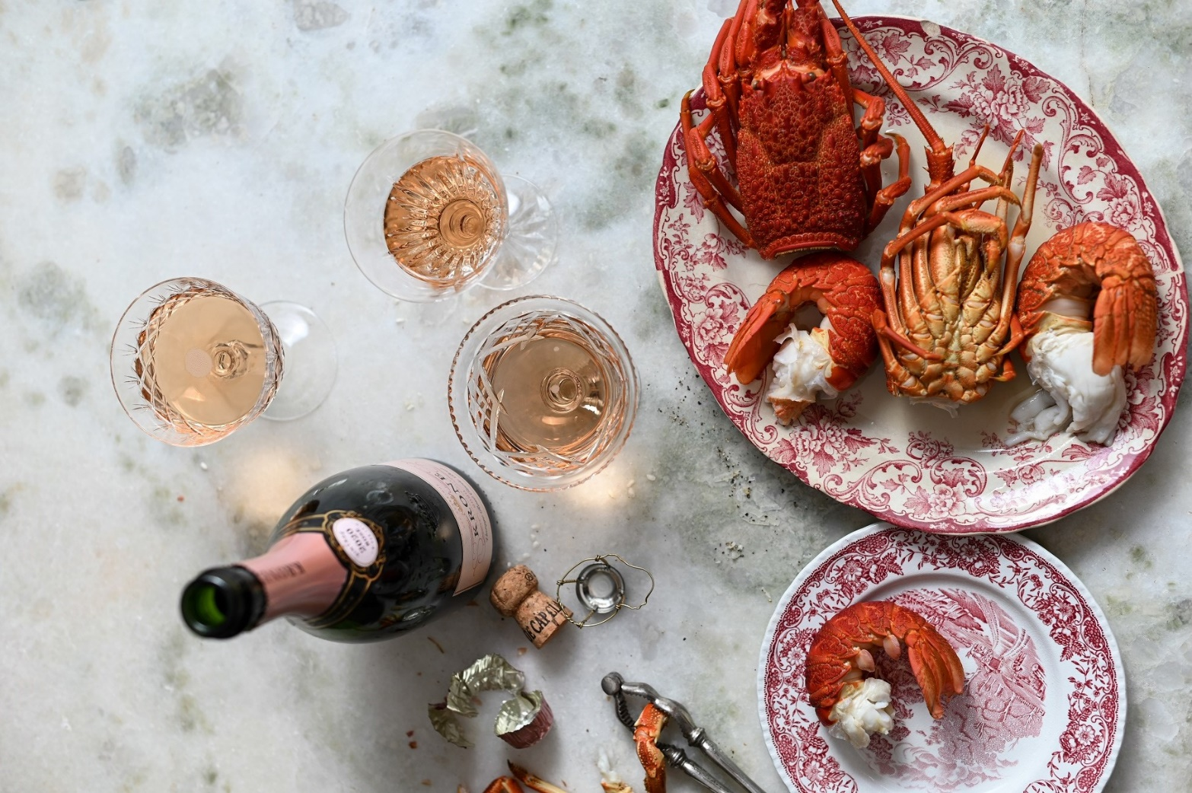

CRAYFISH RISOTTO RECIPE

Prep time: 20 min/Cooking time: 40 min/Serves 4

CRAYFISH AND ARBORIO RICE
INGREDIENTS

- 3-4 whole crayfish
- 1 large head of celery, halved
- 2 large onions or four shallots, peeled and finely chopped
- 8-10 black peppercorns
- 1-2 fennel bulbs, stalks removed (reserving the fronds) and finely chopped
- 1 large clove of garlic, peeled and crushed
- 2 tablespoons of salted butter
- Coarse ground sea salt and black pepper
- 250ml of Krone Vintage Rosé Cuvée Brut
- 1 cup (250ml) of arborio rice, rinsed to get rid of any excess starch
- 1 to 2 litres of water
- A 100g wedge of Parmesan cheese, finely grated

BROWNED BUTTER
INGREDIENTS

- 4 tablespoons salted butter
- 1 teaspoon Spanish smoked paprika
- 2 cloves of garlic, crushed
- Sea salt

METHOD FOR CRAYFISH AND ARBORIO RICE

1. If using live crayfish, swiftly and humanely despatch them with a sharp blade to the head or by immersing them in fresh water for 20 minutes. If using frozen, be sure to defrost entirely before cooking. If using tails, have a readymade fish or vegetable stock at hand and proceed from the next step. For the crayfish stock, set a large pot of water over high heat. Once boiling, plunge the crayfish into the pot, along with half the head of celery (leaves included) and an onion or two shallots. Add in a few black peppercorns if desired. Boil the crayfish for 10 minutes for medium size and 15 minutes if large. Once cooked, remove the crayfish from the pot and set aside to cool. Skim any foam or scum from the top of the stock and strain, discarding the peppercorns, celery and onion. Set the stock aside until needed.

2. Once cooled, twist off the crayfish tails and legs, discarding the body carapace. Use a sharp knife to split each tail in half and remove the alimentary canal, rinsing the tail clean under cold water if needs be. Crack open the legs and reserve the meat. Set the tails aside until needed.

3. In a casserole over medium heat, gently cook up the onion or shallots in the butter until they are soft and translucent. Finely chop the remaining celery and with the chopped fennel, add to the onion and sauté until soft and translucent. Add the garlic and fry over high heat for a further minute or two. Stir to combine and season with salt and pepper.

4. Rinse the arborio rice under cold water until it runs clear. Add the rice to the casserole and stir through the vegetables before deglazing the pot with the Cap Classique. Leave to cook for a minute or two before lowering the heat to medium. Pour in the crayfish stock and stir until all the liquid has been absorbed. If the rice is not yet cooked through, add a little water, stirring throughout.

5. To check that your rice is cooked, simply press a grain between your thumb and forefinger – if it has slight give before squashing, then it is ready. Once cooked, stir in the crayfish leg meat and the grated Parmesan cheese. Keep the risotto warm until ready to serve.

METHOD FOR PAPRIKA BROWNED BUTTER

Melt the butter in a frying pan over medium heat and add in the paprika and garlic. Let the garlic sauté but not brown. Add in the halved crayfish tails and fry – flesh side down – for 2-3 minutes.

TO SERVE

Divide the risotto into four warmed bowls and top each with half a crayfish tail. Finish off the dish by spooning some of the leftover paprika browned butter over the top and garnishing with a fennel frond. The risotto is ready to eat immediately alongside a bottle of chilled Krone Vintage Rosé Cuvée Brut 2020.

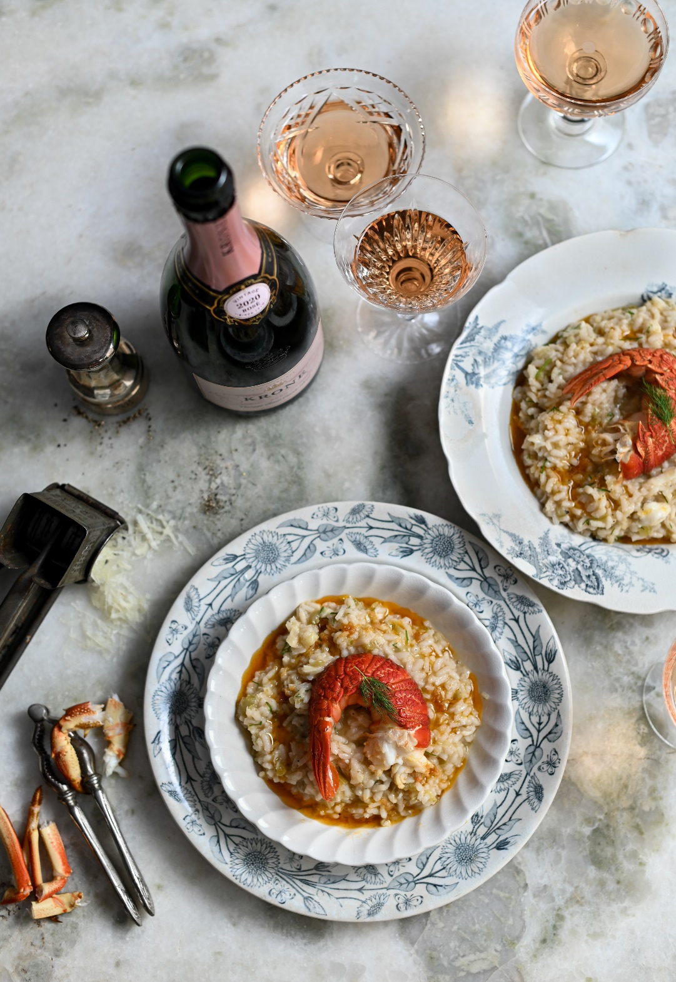

KRONE VINTAGE ROSÉ CUVÉE BRUT 2020

BLEND

Pinot Noir 92%, Chardonnay 8%

TASTING NOTES

Gossamer pink. Like walking into a secret garden, the nose is fragrant and lush, aromatics of wild berries, climbing strawberry vines and the persistent undertone of night lily open to the moon. Grounding this ethereal bouquet is the mineral scent of moist clay. On entry to the palate, waves of cleansing citrus, blood orange and mandarin coalesce to a bright-fruited core of raspberries, strawberries, cranberries and white peach. The acidity is a keen line across the palate, displaying the great tension imbued by the high diurnal swings of the Tulbagh region, only amplified by the inherent freshness of the 2020 vintage. This saline sapidity runs right through complementing the textural creaminess of the lees, a counterpoint to the diaphanous mousse as the wine tapers off into a dry, strawberry-kissed finish.

FOOD PAIRING

Krone Cuvée Brut Rosé delights in food that favours honest expression, from a simple picnic with slivers of charcuterie, crusty sourdough bread, ripe, melty Camembert. A tug-of-war between density and weightlessness, the structure lends itself to the refined too; salmon with crispy skin crackling and wild black rice to rolled porchetta, and duck with cherries.
PURCHASE

Krone Vintage Rosé Cuvée Brut 2020 is available for purchase at the estate, online at https://www.kronecapclassique.co.za/collections/vintage-mcc and is widely available nationally at select liquor retailers and grocers.

APPROXIMATE RETAIL PRICE

R190 per 750ml bottle

VINTAGE ONLY CREATION

The making of vintage-only Krone Cap Classique is a commitment to the vintage showcasing the character of each harvest and celebrating a moment in time and place, the unique hallmarks of every vintage as directed by nature: from soil to vine to bottle. Each vintage tells a story. The Krone winemaking team channels the rain, the sun, the wind into structure, complexity and balance - and seals it all with a cork.

TWEE JONGE GEZELLEN

Established in 1710, a national monument with over 300 years of history, Twee Jonge Gezellen in Tulbagh is the treasured home of Krone, a collection of Vintage-Only, terroir-driven Cap Classiques handcrafted in the traditional method in Krone’s historic underground cellar from the finest most distinctive grapes.

Family-owned, the Rands family purchased the farm in 2012. Brother and sister, Svend and Abigail are involved intimately in all aspects of the estate, from vineyard plantings to marketing. Cellarmaster Rudiger Gretschel leads the winemaking division, a renowned Cape winemaker he pours his considerable knowledge into both the viticulture as well as the vinification, working seamlessly alongside Cap Classique specialist and head winemaker Stephan de Beer. In 2017 the historic estate was reimagined with the interior design being inspired by its rich heritage and original architecture. Today, after lengthy restoration, the farm is both redolent of its history as well as burgeoning with contemporary relevance.

Taste Krone’s vintage Cap Classiques soaking up the majestic views of the picturesque valley and the Winterhoek, Witzenberg and Obiqua Mountains.

The KRONE X WHATIFTHEWORLD GALLERY is a collaborative space offering an immersive experience showcasing African contemporary art in the heart of Tulbagh. Now home to an Artist Residency Programme too.



TASTING ROOM & GALLERY OPENING HOURS

Monday - Saturday: 10:00 - 16:00
Twee Jonge Gezellen is closed on Sundays and Public Holidays

CONTACT DETAILS

Tel: 023 230 0680
Email: info@kronecapclassique.co.za
Website: kronecapclassique.co.za
Facebook: facebook.com/KroneCapClassique
Twitter: @KroneCC
Instagram: @kronecapclassique

Prepared by: Krone:
Posy Hazell ∙ PR & Social Media Consultant Contact: Abigail Rands
E-mail: posy@hazell.co.za E-mail: abigail@kronecapclassique.co.za

