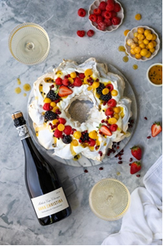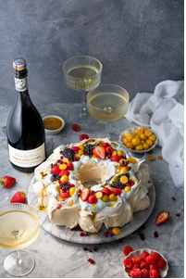

Sense of Place Pavlova wreath with summer berries

By www.thefoodfox.com

There are few better desserts to serve on a hot summer’s day than a beautiful pavlova topped with tufts of whipped cream and seasonal fruit. It is light, textural, sweet and tart, and makes the most beautiful centrepiece for your festive table.

The Anna Christina Cap Classique is part of Stellenbosch Hills’ premium Sense of Place series. The vineyards that this wine was made of, grow on By den Weg Farm - also known for their bountiful berry orchards. Blueberries, blackberries, raspberries and organic strawberries (plus a handful gooseberries) are harvested from the end of spring right through the hot months of summer, adjacent to the Chardonnay vines on the farm. What a pleasure to be enjoying these summer berries as part of our pavlova recipe, along with a glass of the Anna Christina MCC - a true celebration of their “sense of place”.

Ingredients: (serves 6-8)

5 XL egg whites
a pinch of salt
300 g caster sugar
10 ml lemon juice
15 ml corn flour
5 ml vanilla extract
3 tablespoons icing sugar, for dusting (optional)
250 ml fresh cream, whipped to medium stiff peaks
a selection of fresh seasonal berries (2-3 cups)
a few tablespoons passion fruit pulp (fresh or canned)

Method:

Pre-heat oven to 150°C (regular convection) with rack on the middle shelf. Using an electric whisk or stand mixer with balloon whisk, whisk the egg whites in a big, clean bowl until soft peaks form. Gradually add the castor sugar to egg whites while whisking, a tablespoon at a time, until fully incorporated and the mixture is stiff and glossy. Add the lemon juice, corn flour.

Draw a circle on the back of a piece of baking paper - about 23cm in diameter. Draw another circle in the middle, about 10 cm in diameter. Turn the paper over and stick it to a baking sheet using small amounts of pavlova mixture, then use two large spoons to spoon the mixture into a wreath shape on the paper. Transfer it to the oven, immediately turning down the heat to 110°C, then bake for 1 hour 15 minutes. Turn off the oven and leave the pavlova to cool completely, without opening the door (about 2 hours).

Remove pavlova from the oven and keep in an airtight container until ready to use (keep it on the baking paper as long as you can). When ready to serve, carefully remove the baking paper from bottom of pavlova and carefully put it on a serving dish - if it cracks here and there, don’t worry, you can patch it with the whipped cream.

Dust lightly with icing sugar (optional), then top with whipped cream, fresh berries and a few drizzles of passion fruit pulp. Serve at once.

Note: The pavlova can be made a day ahead (undecorated), if kept in an airtight container. Once decorated, it must be served immediately.

